CardKeep 0.6.0 mobile audit
Version 0.6.0
Commit cdcf49d
2026-10-21
Revision 1.1

CardKeep 0.6.0 mobile release audit
Field | Value
Application | CardKeep (com.axialforge.cardkeep)
Version / build | 0.6.0, versionCode 2010 (arm64)
Commit / tag | cdcf49d / v0.6.0
Platform | Android (iOS out of scope: scaffolding only)
Environment | Production (GitHub Releases)
Artifact | CardKeep-0.6.0-arm64-v8a.apk, sha256 CC9B63BC…F52501 (+ armeabi-v7a, x86_64)
Evidence mode | Artifact + runtime (Android 16 emulator; owner's phone not connected)
Identity gate | PASS: the audited APKs are the v0.6.0 release assets; same signing key as earlier releases
Audited on | 2026-10-21
Store policies checked | 2026-10-21, Google Play Console Help and Developer Policy Center (Appendix C)

DECISION: NO-GO
Two reachable data-loss defects and two privacy defects are open. A crash during restore can wipe the whole
contact library (proven by a test), batch-scanned cards can be lost if the app is killed, deleted contacts are
never really deleted, and the app ships Google's ML Kit telemetry library while saying it only goes online for
updates. For Google Play specifically, four more store blockers apply (self-updater, unused media/microphone
permissions, no AAB, no privacy policy). All are fixable; none needs a redesign.
Coverage: 194/231 controls tested (PASS 98 + PASS-WARN 55 + FAIL 41), 21 N/A, 8 NOT TESTED, 5 BLOCKED, 3 MANUAL REVIEW.

Scores (value / coverage of that area)
Area | Score | Coverage | Basis
Security (local, platform, network, input) | 87/100 | 87% (61/69 tested) | 12 open: 2 S2, 7 S1, 3 S0
Privacy (privacy, permissions, logging) | 82/100 | 89% (34/38) | 4 open: 2 S3, 2 S1
Reliability & data integrity | 61/100 | 91% (32/35) | 9 open: 1 S4, 1 S3, 2 S2, 5 S1
UX, accessibility, performance | 94/100 | 88% (21/24) | 5 open: 1 S2, 3 S1, 1 S0
Store (Google Play) | 75/100 | 69% (20/29) | 7 open: 2 S3, 2 S2, 3 S1
Build & supply chain | 97/100 | 71% (29/41) | 4 open: 3 S1, 1 S0

Scores do not override the decision: one S4 data-loss finding alone makes this NO-GO.
Counts (open): Blockers 9 · S4 1 · S3 5 · S2 7 · S1 23 · S0 5 · plus 2 duplicates merged.

Release blockers
ID | Sev
MOB-REL-0001 | S4
MOB-REL-0002 | S3
MOB-PRV-0001 | S3
MOB-PRV-0002 | S3
MOB-STORE-0001 | S3
MOB-STORE-0002 | S3
MOB-STORE-0003 | S2
MOB-STORE-0004 | S2
MOB-STORE-0005 | S1

For the current GitHub channel only the first four rows block a release; the STORE rows block a Play upload.

High and moderate findings (not blockers)
ID | Sev
MOB-SEC-0001 | S2
MOB-SEC-0100 | S2
MOB-REL-0003 | S2
MOB-REL-0004 | S2
MOB-UX-0001 | S2

The 23 S1 and 5 S0 items are in Appendix A (findings index) and their files.

What is missing for a GO
- Fix REL-0001 (journalled, resumable swap; never delete the only copy) and REL-0002 (persist queued captures before reading), with crash-simulation tests.
- Decide on ML Kit telemetry (MOB-PRV-0001): capture traffic on a device; then disable it if possible or disclose it in the README, app and Data safety.
- Purge on delete (MOB-PRV-0002): remove rows and image files after an undo window; exclude tombstones from backups.
- Declare backup rules (MOB-SEC-0001) and say in the app what is and isn't backed up.
- For Play: a Play flavour without the updater, remove plugin permissions with tools:node="remove", AAB + Play App Signing in CI, a published privacy policy, Data safety answers.
- Runtime gaps: phone test of NFC and the real camera, the lock-screen notification text, bmgr backup contents, a profile-build frame-timing run, and an OSV/GHSA lookup for bundled SQLite and OpenCV.

Manual review queue
Item | How to check
ML Kit telemetry traffic | Run the release build on a phone behind a proxy (e.g. PCAPdroid) while scanning; look for firebaselogging-pa.googleapis.com / play.googleapis.com/log
Media / microphone prompts | Use every feature on Android 13+; confirm no media or microphone permission dialog ever appears
Lock-screen reminder text | Set a reminder 2 minutes ahead, lock the phone, read what shows
What Android backs up | adb shell bmgr backupnow com.axialforge.cardkeep with a backup transport, then list the backup
Keystore backup | Confirm a second copy of keys/ exists off this PC (losing it means no more updates)
Known vulnerabilities | Query OSV for sqlite3 3.50.x and OpenCV 4.x versions bundled by sqlite3/opencv_dart
Play content rating, target audience, signing strategy | Owner decisions at Play Console setup

Method
Seven domain audits ran in parallel against the same artifact lineage (identity in Appendix A), each writing structured
findings (audit/findings/) and a coverage table; the consolidation merged duplicates (MOB-AND-0001 into MOB-SEC-0001,
MOB-BLD-0001 into MOB-STORE-0002) and re-ran the one data-loss proof that an auditor could not finish. No app code was
changed during the audit. Runtime checks used the shipped x86_64 APK on the emulator; phone-only behaviour (NFC, the
real camera, battery saver) is BLOCKED here and listed in the phone test sheets.
Appendices: A scope, identity and attack surface · B inventories (permissions, data, Data safety draft) and SBOM ·
C store checklist and policies · D runtime evidence and screenshots · Findings index · Coverage & Evidence Matrix ·
all findings.

MOB-A11Y-0001 - Round header buttons (DiscButton) are 46x46 dp, below the 48 dp touch-target minimum
Severity S1 | Status open | Confidence high | Basis runtime | Blockers []
Description. DiscButton draws its tap area as a fixed 46x46 dp box. The UI dump of the shipped x86_64 release build reports these controls at 46x46 dp, while Android accessibility guidance and the Accessibility Scanner flag targets under 48x48 dp. Other app buttons (IconButton, chips, list rows) measure 48 dp or more, so only this shared widget is short. The labels are present (semanticLabel: tooltip), so TalkBack is fine; only target size is affected. S1: 2 dp short, buttons are well separated.
Steps to reproduce. 1. Open Contacts. 2. adb shell uiautomator dump; read the bounds of content-desc="Menu" and "Add contact".
Expected. At least 48x48 dp.
Observed. 138x138 px at density 480 (3.0) = 46x46 dp; same for detail Back/Edit, Review queue "Scan cards", Duplicates "Check the whole library again".
Evidence.
- UI dump (Contacts): View desc=Menu w=46 h=46, View desc=Add contact w=46 h=46
- UI dump (detail): View desc=Back w=46 h=46, View desc=Edit w=46 h=46
- Screenshots: audit/artifact/screens/01_launch_empty.png, audit/artifact/screens/09_detail_long.png
Impact. User: slightly harder to hit for users with motor impairments; will be flagged by Accessibility Scanner / Play pre-launch report.
Recommended remediation. Make the SizedBox 48x48 (or wrap in ConstrainedBox(minWidth/minHeight: 48)) keeping the 46 dp visual disc.
Verification procedure. Re-dump the four screens; every DiscButton reports >= 48x48 dp.
References. WCAG 2.2 SC 2.5.8 Target Size (Minimum); Android accessibility "touch target size 48dp"; MASVS n/a.

MOB-A11Y-0002 - Scan mode selector (One card / Batch / Pile) has 34 dp tall touch targets
Severity S1 | Status open | Confidence high | Basis runtime | Blockers []
Description. On the Scan screen the three mode buttons report 80x34, 59x34 and 46x34 dp in the UI dump. Height is well under 48 dp, and "Pile mode" is also under 48 dp wide. The scanner is used one-handed at events, which makes small targets more costly.
Steps to reproduce. 1. Contacts > Scan card, allow camera. 2. adb shell uiautomator dump; read the bounds of "One card mode", "Batch mode", "Pile mode".
Expected. Each target at least 48x48 dp (visual pill can stay smaller, with padding to the tap area).
Observed. Button One card mode w=80 h=34, Button Batch mode w=59 h=34, Button Pile mode w=46 h=34.
Evidence. UI dump above; screenshot audit/artifact/screens/13_scan.png.
Impact. User: mis-taps between modes; Accessibility Scanner flag.
Recommended remediation. Give the mode buttons minimumSize: Size(48, 48) / tapTargetSize: MaterialTapTargetSize.padded.
Verification procedure. Re-dump the Scan screen; all three report >= 48 dp in both dimensions.
References. WCAG 2.2 SC 2.5.8; Android touch target guidance (48 dp).

MOB-AND-0001 - "Android auto-backup is on by default, so the contacts database and card photos go to Google cloud and device-transfer backups"
Severity S2 | Status duplicate (tracked as MOB-SEC-0001) | Confidence high | Basis artifact | Blockers [privacy]
Consolidation: same defect as MOB-SEC-0001; counted there, not here.

Android auto-backup is on by default, so the contacts database and card photos go to Google cloud and device-transfer backups

Description
The merged release manifest does not set android:allowBackup, android:fullBackupContent or android:dataExtractionRules, so the Android default (allowBackup=true) applies. Auto Backup and device-to-device transfer then include app_flutter/card_organizer.sqlite and app_flutter/cards/. The app's own backup design (user-chosen .zip via SAF) implies on-device-only intent, and the threat model lists 'backups reading it' as a main risk. After uninstall and reinstall on a phone signed into the same Google account, data may silently come back; this is not documented. Google cloud backups are end-to-end encrypted with the lock-screen credential on Android 9+, which limits but does not remove the exposure.

Expected behaviour
Backup behaviour is a deliberate, documented choice: allowBackup=false plus dataExtractionRules excluding the database (Android 12+), or an explicit include list stated in the privacy notes.

Observed behaviour
Default full Auto Backup of contact PII; reinstall behaviour undocumented.

Recommended remediation
Add android:allowBackup="false" and a data_extraction_rules.xml that excludes cloud-backup and device-transfer of the database and cards/ (or document the intent if keeping it). Reflect it in the privacy text / Data Safety.

Verification procedure
Rebuild; manifest-xmltree shows allowBackup=false and dataExtractionRules; adb shell bmgr backupnow com.axialforge.cardkeep reports the package not eligible.

MOB-API-0001 - "Update download falls back to a size-only check when GitHub lists no SHA-256 digest, and has no maximum size"
Severity S1 | Status open | Confidence high | Basis static | Blockers []

MOB-BLD-0001 - "Shipped APK declares RECORD_AUDIO, READ_MEDIA_VIDEO and READ_MEDIA_AUDIO that the app never uses"
Severity S2 | Status duplicate (tracked as MOB-STORE-0002) | Confidence medium | Basis artifact | Blockers [store]
Consolidation: same defect as MOB-STORE-0002; counted there, not here.

Shipped APK declares RECORD_AUDIO, READ_MEDIA_VIDEO and READ_MEDIA_AUDIO that the app never uses

Description
The release manifest merges in RECORD_AUDIO (no maxSdkVersion), READ_MEDIA_VIDEO and READ_MEDIA_AUDIO from plugins. CardKeep only takes still card photos and imports .vcf/.csv/.zip through SAF. Unused permissions widen the surface, show on the app's permission page, and READ_MEDIA_* fall under Google Play's Photo and Video Permissions policy when the app moves to Play (M9). Presence is certain; the exact contributing plugin is medium confidence.

Expected behaviour
Only permissions the app uses ship.

Observed behaviour
Three unused dangerous permissions ship.

Recommended remediation
Add uses-permission entries with tools:node="remove" for RECORD_AUDIO, READ_MEDIA_VIDEO, READ_MEDIA_AUDIO (and READ_MEDIA_IMAGES if only the system photo picker is used); construct CameraController with enableAudio: false; re-test capture and gallery import.

Verification procedure
aapt2 dump permissions on the new APK lists none of the removed permissions; capture and gallery import still work on the emulator.

MOB-BLD-0002 - "Release build silently falls back to the debug signing key when key.properties is missing"
Severity S1 | Status open | Confidence high | Basis static | Blockers []

Release build silently falls back to the debug signing key when key.properties is missing

Description
If key.properties is absent (a CI secret unset or renamed), flutter build apk --release still succeeds and signs with the debug key, and release.yml would publish it. Installed users could not update to it (signature mismatch fails safe), but a debug-signed public release breaks the update chain. No CI step verifies the signer certificate before upload.

Expected behaviour
A tag build fails if the release key is unavailable, and CI checks the signer SHA-256 against the known release certificate.

Observed behaviour
Silent fallback; no certificate check.

Recommended remediation
Fail the build in CI when key.properties is missing (e.g. if System.getenv('CI') != null), and add apksigner verify --print-certs compared to the known cert SHA-256 (4ffa7fe0...3a2820) before publishing.

Verification procedure
Run the release workflow on a throwaway tag with the keystore secret removed: it must fail.

MOB-BLD-0003 - "CI actions are pinned to moving major tags, and releases carry no provenance, checksums file or SBOM"
Severity S1 | Status open | Confidence high | Basis static | Blockers []

CI actions are pinned to moving major tags, and releases carry no provenance, checksums file or SBOM

Description
The release job holds the signing keystore secrets and contents:write, yet third-party actions are referenced by mutable tags. A compromised tag of subosito/flutter-action or softprops/action-gh-release would run with access to the keystore. No build attestation, SHA256SUMS or SBOM is attached to the GitHub Release, and the NDK is fetched via sdkmanager without a checksum pin. Mitigation present: tag-vs-pubspec version check, flutter test before build, Flutter version pinned to 3.47.0.

Expected behaviour
Third-party actions pinned to full commit SHAs; provenance attestation and checksums published.

Observed behaviour
Tag-pinned actions, no attestation or checksums.

Recommended remediation
Pin each action to a commit SHA (Dependabot can bump them), add actions/attest-build-provenance and a SHA256SUMS asset, optionally generate a CycloneDX SBOM in CI.

Verification procedure
grep 'uses:' in workflows shows 40-hex SHAs; next release page shows attestation and SHA256SUMS.

MOB-BLD-0004 - "R8 mapping and Dart symbol files are not archived, so release crashes cannot be symbolicated"
Severity S1 | Status open | Confidence high | Basis static | Blockers []

R8 mapping and Dart symbol files are not archived, so release crashes cannot be symbolicated

Description
R8 runs on release (proguard-rules.pro is applied, and CLAUDE.md records a 0.2.x R8 stripping bug found only in release), but mapping.txt is discarded with the runner and Dart code is not built with --split-debug-info, so no symbol files exist for the shipped binaries. No user risk; it limits diagnosing field crashes.

Expected behaviour
mapping.txt (and symbols if adopted) retained per release.

Observed behaviour
Not retained.

Recommended remediation
Upload build/app/outputs/mapping/release/mapping.txt with actions/upload-artifact (long retention) or as a release asset.

Verification procedure
Next tag's workflow run lists a mapping artifact.

MOB-BLD-0005 - "APK is signed with scheme v2 only; v3 (key rotation) is not enabled and there is no recorded key backup"
Severity S0 | Status open | Confidence high | Basis artifact | Blockers []

APK is signed with scheme v2 only; v3 (key rotation) is not enabled and there is no recorded key backup

Description
apksigner shows v2 only. v2 is sufficient for minSdk 24, but without v3 the key can never be rotated in place for sideloaded users, so loss or compromise of the single key ends the update chain. Where the offline backup of keys/ lives is not recorded in the repo docs.

Expected behaviour
v2+v3 signatures and a documented key backup.

Observed behaviour
v2 only.

Recommended remediation
Set enableV3Signing = true in the release signing config; record the keystore backup location in CLAUDE.md.

Verification procedure
apksigner verify reports v3 true.

MOB-PERF-0001 - About 80 MB of memory stays allocated after leaving the Scan screen
Severity S0 | Status open | Confidence medium | Basis runtime | Blockers []
Description. Total PSS rose from 86.9 MB (idle on Contacts) to 182.7 MB with the Scan screen open (native heap 25.8 MB -> 99.2 MB). After closing Scan and visiting eleven other screens, PSS stayed at 165-167 MB. It is likely the ML Kit text/barcode recognizers and OpenCV buffers held by long-lived providers rather than a growing leak (it did not grow further), so S0. On low-RAM devices (minSdk 24 phones with 2-3 GB) this raises the chance the app is killed in the background.
Evidence.
`
idle (Contacts) TOTAL PSS: 86891 KB Native Heap 25836 KB
Scan open TOTAL PSS: 182749 KB Native Heap 99196 KB
5 s after closing Scan TOTAL PSS: 167490 KB
after 11 more screens TOTAL PSS: 165847 KB
`
(adb shell dumpsys meminfo com.axialforge.cardkeep). Screenshot audit/artifact/screens/13_scan.png.
Impact. User: slightly higher background-kill risk on low-memory phones.
Recommended remediation. Close recognizers / release OpenCV mats when the Scan route is disposed (autoDispose providers), and re-check with repeated open/close cycles.
Verification procedure. Open/close Scan 5 times; PSS returns to within ~20 MB of idle and does not climb.
References. Android "Manage your app's memory", checked 2026-10-21.

MOB-PRV-0001 - "ML Kit ships Google's datatransport telemetry stack, contradicting the 'only goes online for updates / no analytics' claims"
Severity S3 | Status open | Confidence medium | Basis artifact | Blockers [privacy, store]
Evidence and reasoning in front matter. Related: MOB-STORE-0005 (Data Safety answers not prepared).

MOB-PRV-0002 - "Deleting a contact never removes its data: tombstone only, card photos, logos and contact details kept forever and copied into every backup"
Severity S3 | Status open | Confidence high | Basis static | Blockers [privacy]
See front matter.

MOB-PRV-0003 - "before_restore/ fallback copy of the whole library is kept indefinitely with no way to discard it"
Severity S1 | Status open | Confidence high | Basis static | Blockers []
See front matter.

MOB-PRV-0004 - "open_filex and camera_android_camerax also merge legacy READ/WRITE_EXTERNAL_STORAGE that the app never uses"
Severity S1 | Status open | Confidence high | Basis artifact | Blockers []
See front matter.

MOB-REL-0001 - Restore swap is not crash-safe; a re-run after a partial swap deletes the user's pre-restore data and opens an empty database
Severity S4 | Status open | Confidence high | Basis runtime | Blockers [data-loss]
Description. applyPendingRestore decides whether to run only by checking that restore_pending/.ready exists. That marker is removed last of all (:185, staged.delete). The steps before it are not idempotent:
- It deletes before_restore/ (:173).
- It moves the live DB, WAL and SHM into before_restore/ (:175-178).
- It moves cards/ into before_restore/ (:180).
- It moves the staged DB into place (:182).
- It moves the staged cards/ into place (:184).
- It deletes restore_pending/ (:185).
If the process dies after step 2 and before step 6 (the OS kills a slow start, the battery dies, or the user force-stops a start that looks frozen while a large cards/ tree is being renamed), .ready is still there on the next start. The re-run then does the following:
- Killed after step 2, 3 or 4: step 1 deletes before_restore/, which by now holds the user's only copy of the original database and card images. If the staged DB was still in restore_pending, the restore then completes, but the safety copy is gone for good.
- Killed after step 4 or 5: step 1 deletes the original data, and step 2 moves the *restored* DB into before_restore/. Step 4 then throws FileSystemException, because the staged DB has already been moved. main() swallows the error (debugPrint, main.dart:17). drift finds no card_organizer.sqlite and creates an empty database. The user sees an empty app. The original data is gone. The restored data sits in a hidden folder that nothing in the UI can reach (MOB-REL-0003). .ready is still present, so every later start repeats the failure and deletes `before_restore/` again, which destroys the restored data too, while the new empty database is moved aside each time.
The rename steps themselves are fast. What makes the crash window realistic is the directory renames, which run while the app shows no UI before runApp, and the fact that a single interruption costs everything with no warning. The consequence is total loss of the contact database, so the severity is S4.
Preconditions. The user restored a backup and the app restarts. The process dies partway through applyPendingRestore.
Steps to reproduce (deterministic simulation).
- In a temp docs folder, create card_organizer.sqlite ("RESTORED"), before_restore/card_organizer.sqlite ("ORIGINAL") and restore_pending/.ready, with no staged DB. This is the state after a kill following step 4.
- Call applyPendingRestore(docs).
- Trace of the code: before_restore/ with ORIGINAL is deleted at :173. RESTORED is moved into before_restore/ at :177. File(restore_pending/card_organizer.sqlite).rename throws at :182. docs has no database, and .ready is still present.
Confirmed by a run (consolidation, 2026-10-21). A unit test set up the state after a kill following step 4 (live DB = restored copy, before_restore/ = original, restore_pending/.ready present, staged DB already moved) and called applyPendingRestore(docs). Output:
`
error: PathNotFoundException
live db exists: false
before_restore holds: RESTORED
.ready still there: true
`
The original database was deleted, the live database is gone (drift will create an empty one), and the marker remains, so the next start repeats the loss. The test file was removed after the run.
Expected. The swap is resumable or transactional. before_restore is never deleted while it holds the only copy of user data. A failed swap is rolled back and reported.
Root cause. A single completion marker is checked at the start and removed at the end. The delete-first handling of the fallback folder is not idempotent.
Remediation.
- Write a journal file (restore_state: moving_old, moving_new, done) and resume from the recorded phase.
- Delete the old before_restore only after the new swap has finished and the database opens.
- Rename restore_pending/.ready to .applying before step 1, and if .applying is found at start, roll back from before_restore.
- Surface failures to the user instead of swallowing them in main().
Verification. Unit tests that simulate a kill after each step (set up each intermediate state and call applyPendingRestore again) and assert that either the original or the restored database ends up in docs/ and no copy is lost.
References. CWE-367 (TOCTOU-style non-atomic multi-step operation), MASVS-RESILIENCE (data integrity).

MOB-REL-0002 - Queued scan captures exist only in memory; killing the app during batch scanning loses them
Severity S3 | Status open | Confidence high | Basis static | Blockers [data-loss]
Description. The scanner accepts up to 8 captures ahead of the reader (ScanWorker.maxQueued). scan_screen.dart:240 and :307 call worker.add(ScanJob(bytes)) with no pending file. The crash-safe copy is only written by ScanPipeline.process (scan_pipeline.dart:122) once the job reaches the head of the queue. On top of that, ImageStore.commit deletes the pending copy (image_store.dart:55) *before* OCR, QR, logo extraction and queue.enqueue run (scan_pipeline.dart:132-134, scan_worker.dart:65). ML Kit OCR takes seconds per card.
The stated contract ("never lose a capture", image_store.dart:30-31, app.dart:44-45) therefore fails in two windows:
- Every capture still waiting in _jobs (up to 7) has no file on disk.
- The capture being read has already lost its pending file and has no cards row yet. Its images are left orphaned in cards/, and nothing references them.
Severity is S3 rather than S4 because the paper card can usually be scanned again. At an event, though, the loss is silent and the card may already have been handed back.
Preconditions. Several captures queued ("Reading N" above 1), or a capture being read.
Steps to reproduce.
- Batch-scan or gallery-import 5 or more cards quickly.
- While "Reading N" shows, swipe the app away from Recents (or let the OS kill it).
- Reopen the app. Start-up recovery reads at most the one file still in pending/. The other captures are gone, and no message says so.
Expected. Every accepted capture is on disk before it is acknowledged. The pending copy is deleted only after the cards row is committed.
Observed (code). Recovery (scan_worker.dart:44-50) can only find files in pending/, and queued jobs never reach pending/ before they are processed.
Root cause. savePending runs in the pipeline instead of at capture time. The pending copy is removed during the image commit instead of after the enqueue.
Remediation. Call store.savePending in ScanWorker.add (or in scan_screen before add) and pass it as pending. Delete the pending copy only after queue.enqueue succeeds.
Verification. Test 1: queue 3 jobs behind a blocking fake pipeline and assert that 3 files exist in pending/. Test 2: throw after commit and before enqueue, and assert that the pending file still exists.

MOB-REL-0003 - A failed or bad restore is silent, and the before_restore safety copy cannot be reached from the app
Severity S2 | Status open | Confidence high | Basis static | Blockers []
Description. applyPendingRestore keeps the old database and images in before_restore/, but nothing else in lib/ refers to that folder (grep -rn before_restore lib finds only backup.dart). There is no undo for a restore.
If the swap throws, main() only logs it with debugPrint('Restore failed: $e'). The app then opens whatever is in place, which can be a new, empty database (see MOB-REL-0001), and the user is never told.
A staged database can pass the hash check and still fail to open, for example a backup taken from an already-damaged database. In that case drift fails at open, and nothing rolls back to the old copy automatically.
Each new restore deletes the previous before_restore without asking (backup.dart:173), so there is only one level of fallback. One level is acceptable. Having no way to reach it is the defect.
Expected.
- A failed swap rolls back from before_restore and tells the user.
- After a restore, an "Undo restore" option stays available until the next restore.
Remediation.
- Wrap the swap in rollback logic, record the outcome in a marker file, and show it in a snackbar on the next start.
- Open the new database once and run PRAGMA integrity_check before discarding the old copy.
- Add an "Undo last restore" action that stages before_restore.
Verification. Test: stage a backup whose database bytes are not SQLite but whose hashes are valid. After apply and open, the old database is back in place and the failure is reported.

MOB-REL-0004 - An offline or interrupted update download throws an uncaught error and leaves the sheet on its progress bar
Severity S2 | Status open | Confidence high | Basis static | Blockers []
Description. Updater.check turns every network error into an UpdateException (updater.dart:103-111), so the update check fails gracefully offline. That part passes domain 20.
Updater.download does not do the same. Neither client.send(req).timeout(20s) (:167) nor the await for loop over resp.stream (:172) is wrapped. A network loss raises a SocketException, ClientException, TimeoutException or HttpException. _install catches only on UpdateException (update_sheet.dart:50), so:
- _progress stays set and the progress bar stays on screen;
- no error message appears;
- the exception surfaces as unhandled.
A connection that stalls without closing never ends, because the stream has no idle timeout. The partial APK stays in the temp folder until the next attempt deletes it (:165).
Steps to reproduce.
- Open the update sheet while online, with an update available.
- Turn on airplane mode.
- Tap Install.
Expected. "The download did not work. Check your connection." with a way to retry.
Remediation.
- Wrap the send and the stream loop in try/catch and rethrow as UpdateException.
- Add an idle timeout to the stream (resp.stream.timeout(...)).
- In the sheet, also catch generic errors and reset _progress.
Verification. Unit test with a MockClient that throws mid-stream, asserting an UpdateException. Runtime check: airplane mode during a download on the emulator.

MOB-REL-0005 - A capture that always fails to process is retried on every launch, with a recurring "Reading 1 card left from last time"
Severity S1 | Status open | Confidence medium | Basis static | Blockers []
Description. Sometimes pipeline.process throws before commit, for example on an undecodable JPEG or an opencv error in the isolate. The worker swallows the error (catch (_) {} at scan_worker.dart:71) and leaves the pending file "for the next recovery".
There is no retry count, no quarantine and no message to the user. Every launch reads the file again, fails again, and shows the snackbar again. The user cannot see the file or remove it.
Remediation. Count attempts, either in the file name or in a sidecar file. After 2 failures, move the capture to the queue as a "could not read" item the user can discard, or move it to pending/failed/.
Verification. Test with a pipeline that always throws for one file: after two recover() calls, that file is no longer re-queued.

MOB-REL-0006 - Several multi-step writes are not in a transaction (job change, import, event delete, card link)
Severity S1 | Status open | Confidence high | Basis static | Blockers []
Description. Merge, undo, retire, moveFollowup, contact save/delete/restore and the tag operations all use db.transaction (12 call sites). The methods below do not:
- `changeJob` marks the old role *former* (:281), inserts the new role, and then updates emails and roles. An error after the first write leaves the person with no current role.
- `importContacts` saves each contact, then merges or tombstones it in separate steps. A kill partway through leaves the file half imported, and "skipped" duplicates leave tombstoned rows behind.
- `EventsRepository.delete` ends the event's sessions and tombstones the event in two separate statements.
- `CardQueueRepository.link` runs up to three updates: the logo, the met-at event, and the card status. If it fails after the person is updated, the card stays in the queue, and a retried autoSave creates a duplicate contact.
These statements are quick, so being killed between them is unlikely. Errors are the more realistic trigger.
Remediation. Wrap each of these method bodies in db.transaction. For import, use one transaction per contact.
Verification. Fault-injection tests that make a later step throw, then assert that no partial rows remain.

MOB-REL-0007 - Reminder sync calls cancelAll, which also clears today's reminder already shown; ids come from String.hashCode
Severity S1 | Status open | Confidence medium | Basis static | Blockers []
Description. sync calls _plugin.cancelAll() and then re-schedules only follow-ups dated in the future. On Android, cancelAll also removes notifications that are already showing. A reminder that fired at 08:00 today therefore vanishes the next time sync runs, which is on app start or any follow-up edit, before the user has acted on it.
Ids are personId.hashCode & 0x3fffffff. The Dart VM computes string hash codes deterministically, so the ids are stable. Two people can still collide, in which case one reminder replaces the other. The chance is about n^2/2^31, roughly 0.05% with 1,000 open follow-ups. That is low, but nothing guards against it.
Remediation.
- Diff against pendingNotificationRequests() and cancel only ids that are no longer wanted.
- Assign ids from a stored counter instead of from hashCode.
Verification. Fake-plugin test: re-syncing an unchanged list cancels nothing.

MOB-REL-0008 - Card images are content-addressed, but discarding a card deletes them without checking whether another card uses the same hash
Severity S1 | Status open | Confidence medium | Basis static | Blockers []
Description. commit stores image files by sha256 and skips files that already exist ("Idempotent"). Rectification is deterministic, so importing the same gallery photo twice creates two cards rows with the same front_sha256. discard(cardId) calls store.delete(hash) without checking whether another live card still references that hash. The other card, which may already be saved to a contact, loses its images.
Undo (restore) brings back the card row but not the deleted files.
Remediation.
- Delete the files only when no live card references the hash.
- Delay file deletion until the undo window has closed.
Verification. Test: create two cards with the same hash, discard one, and assert that the other card's files still exist. Also assert that undo restores the images.

MOB-REL-0009 - No test runs the v1 to v2 to v3 schema upgrade, which every restore of an older backup depends on
Severity S1 | Status open | Confidence high | Basis static | Blockers []
Description. onUpgrade creates not_duplicates at v2 and adds 4 columns at v3 (tables.dart:43-45, 83). The new columns are nullable or have constant defaults, and the FTS table and indexes are untouched, so static review finds the upgrade correct.
No test, however, opens a v1 or v2 database and upgrades it:
- grep -rn migrat test finds nothing;
- schema_test.dart only checks a fresh create;
- there are no drift schema dumps.
backup.dart:168 relies on older backups being "migrated by the normal upgrade", so this untested path runs on every restore of an older backup.
Remediation. Add drift_dev schema dump snapshots for v1 to v3 and a SchemaVerifier migration test, plus a test that restores a v1 backup fixture.
Verification. The new tests pass in CI.

MOB-SEC-0001 - "Backup scope is undeclared: allowBackup defaults to true with no dataExtractionRules, so the contacts DB, card photos and weekly backup zips go to Google cloud backup and device transfer"
Severity S2 | Status open | Confidence high | Basis artifact | Blockers []

MOB-SEC-0002 - "Follow-up reminders show the contact's name, company and event on the lock screen (no visibility or publicVersion set)"
Severity S1 | Status open | Confidence high | Basis static | Blockers []

MOB-SEC-0003 - "Camera captures (takePicture files in the cache dir) are read into memory and never deleted"
Severity S1 | Status open | Confidence medium | Basis static | Blockers []

MOB-SEC-0004 - "No FLAG_SECURE or recents protection: contact screens appear in the recents thumbnail and in screenshots"
Severity S0 | Status open | Confidence high | Basis static | Blockers []

MOB-SEC-0005 - "Contacts database, card images and backup zips are stored unencrypted (roadmap decision D3 still open)"
Severity S0 | Status open | Confidence high | Basis static | Blockers []

MOB-SEC-0006 - "Incoming vCard intent reads any URI without checking scheme or authority (confused-deputy read of CardKeep's own private files)"
Severity S1 | Status open | Confidence medium | Basis static | Blockers []

MOB-SEC-0007 - "debugPrint error logging runs in release, and clipboard copies of contact details are not flagged sensitive"
Severity S0 | Status open | Confidence medium | Basis static | Blockers []

MOB-SEC-0100 - "CSV import is quadratic: the separator is re-detected by splitting the whole file at every comma, so a few-thousand-row CSV freezes the app"
Severity S2 | Status open | Confidence high | Basis static | Blockers [quality]

MOB-SEC-0101 - "OCR text parser regexes are super-linear on long lines (20k digits 13 s, 50k chars 84 s)"
Severity S1 | Status open | Confidence medium | Basis static | Blockers []

MOB-SEC-0102 - "Backup restore trusts the zip's own manifest: unlisted files are staged unverified, the database is not integrity-checked, and there is no size limit"
Severity S1 | Status open | Confidence high | Basis static | Blockers []

MOB-SEC-0103 - "Opening a malformed website value (e.g. 'javascript:alert(1)' from a vCard or QR) throws an uncaught FormatException"
Severity S1 | Status open | Confidence high | Basis static | Blockers []

MOB-STORE-0001 - "In-app APK self-updater and REQUEST_INSTALL_PACKAGES are not allowed in a Play build"
Severity S3 | Status open | Confidence high | Basis artifact | Blockers [store]
Blocks Play submission only. Fine for GitHub Releases.

MOB-STORE-0002 - "Plugin-merged READ_MEDIA_IMAGES/VIDEO/AUDIO and RECORD_AUDIO are declared but no feature needs them"
Severity S3 | Status open | Confidence medium | Basis artifact | Blockers [store]
Blocks Play submission (media permissions); least-privilege improvement for GitHub.

MOB-STORE-0003 - "CI builds split APKs only; no AAB and no Play App Signing setup"
Severity S2 | Status open | Confidence high | Basis static | Blockers [store]

MOB-STORE-0004 - "No privacy policy URL and no in-app privacy policy link"
Severity S2 | Status open | Confidence high | Basis static | Blockers [store]

MOB-STORE-0005 - "Data safety answers not prepared; they depend on the Play build contents"
Severity S1 | Status open | Confidence high | Basis static | Blockers [store]

MOB-STORE-0006 - "README is stale: 'What it does (0.2.0)', shipped features listed under 'What's next', removed Medium theme named"
Severity S1 | Status open | Confidence high | Basis static | Blockers [quality]

MOB-STORE-0007 - "Roadmap still names app id com.axialforge.card_organizer; shipped id com.axialforge.cardkeep becomes permanent at first Play upload"
Severity S1 | Status open | Confidence high | Basis static | Blockers []

MOB-UX-0001 - Drawer destinations pile up on the back stack; Back walks through every section visited before leaving the app
Severity S2 | Status open | Confidence high | Basis runtime | Blockers []
Description. Opening top-level sections from the navigation drawer pushes each one onto the stack instead of replacing the current section. After visiting Events, Career moves, Review queue, Follow-ups, Duplicates, Tags (and others) via the drawer, system Back steps through each of them in reverse before reaching Contacts and exiting. Some entries (Export and backup, My card, Settings) did not stay on the stack, so the behaviour is also inconsistent between drawer items. Android's navigation principle is that top-level destinations reached from a drawer are siblings: Back from any of them goes to the start destination.
Steps to reproduce. 1. From Contacts open the drawer and visit Events, Career moves, Review queue, Follow-ups, Duplicates, Tags, Export and backup, Settings, Tap cards in turn. 2. Press Back repeatedly.
Expected. Back from a top-level section returns to Contacts; next Back leaves the app.
Observed. 8 Back presses needed:
`
1 : MainActivity | Tags
2 : MainActivity | Check the whole library again (Duplicates)
3 : MainActivity | Follow-ups
4 : MainActivity | Scan cards (Review queue)
5 : MainActivity | Career moves
6 : MainActivity | Events
7 : MainActivity | Add contact (Contacts)
8 : NexusLauncherActivity (app left)
`
Evidence. Command output above (adb input keyevent BACK + dumpsys window mCurrentFocus + UI dump per step). Screens: audit/artifact/screens/20_Events.png .. 30_Tap_cards_NFC.png.
Impact. User: confusing, "stuck in the app" feel; growing stack also keeps every visited screen alive in memory.
Recommended remediation. Use context.go() (replace) for drawer destinations, push only for detail/sub screens; make all drawer items consistent.
Verification procedure. Repeat the steps; Back from any drawer section lands on Contacts, then exits.
References. Android "Principles of navigation" (fixed start destination; Back to start from top-level), checked 2026-10-21.

MOB-UX-0002 - "Sync to desktop" is a live drawer entry that opens a "coming in 0.8" placeholder
Severity S1 | Status open | Confidence high | Basis runtime | Blockers []
Description. The drawer lists "Sync to desktop" alongside working features. Tapping it opens a screen that only says "Sync to desktop is on the way - This part of the app arrives in version 0.8." Shipping unfinished features as navigable entries reads as broken to users, and Google Play's minimum functionality guidance discourages placeholder content. Low severity because it is clearly labelled and harmless.
Steps to reproduce. Drawer > Sync to desktop.
Expected. Entry hidden until the feature exists (or clearly marked "Coming soon" in the drawer itself).
Observed. Placeholder screen.
Evidence. audit/artifact/screens/27_Sync_to_desktop.png; UI dump of drawer: Button Sync to desktop w=308 h=50 (audit/artifact/screens/02_drawer.png).
Impact. User: dead end. Business: minor store-review risk once on Play (placeholder features).
Recommended remediation. Hide the entry behind a feature flag until 0.8, or mark it "Coming soon" in the drawer.
Verification procedure. Drawer no longer shows the entry (or shows it marked).
References. Google Play "Minimum functionality" policy, checked 2026-10-21.

Coverage & Evidence Matrix
Every control from every domain auditor, merged. States: PASS, PASS-WARN, FAIL, BLOCKED, N/A, NOT TESTED, MANUAL REVIEW. Some auditors used WARN/PARTIAL/NOTE; they count as PASS-WARN (met with a concern) in the totals.

G1-build-supply
Audited artifact: CardKeep-0.6.0-arm64-v8a.apk (v0.6.0, cdcf49d). Tools: aapt2/apksigner/zipalign 36.0.0. Date 2026-10-21.
Note: the brief listed "21 Dependencies/SBOM"; in domains.md that control set is domain 18 (21 is logging). Covered as 18.
Domain | Control | State | Basis | Evidence | Finding
02 | debuggable off in release | PASS | artifact | manifest-xmltree.txt: no android:debuggable attribute | -
02 | Debug endpoints, test credentials, dev menus, mock services, staging URLs absent | PASS | static | Only outbound host api.github.com (updater.dart:106); no staging host found; Appendix A outbound table | -
02 | Test ad IDs absent | N/A | static | No ads SDK in pubspec.lock | -
02 | Verbose logging off | NOT TESTED | - | Logcat review belongs to logging domain 21 auditor | -
02 | Dev certs removed / no user-CA trust | PASS | artifact | No networkSecurityConfig, no cleartext flag; defaults (no user CA for targetSdk 36) | -
02 | Signing config correct, dev/prod keys separated | PASS-WARN | artifact | apksigner: verifies, 1 signer, cert matches prior releases (Appendix A); debug-key fallback in build.gradle.kts:47 | MOB-BLD-0002
02 | Signing scheme | PASS-WARN | artifact | v2 true, v3 false | MOB-BLD-0005
02 | Package ID and versioning correct | PASS | artifact | badging: com.axialforge.cardkeep 0.6.0; pubspec 0.6.0+10; release.yml tag-vs-pubspec check | -
02 | versionCode scheme across ABI splits monotonic | PASS | artifact | arm64 2010 = 2000+10 (Flutter split offsets 1000/2000/4000 x 1 + build); build number increments per release | -
02 | Optimization / minification on | PASS | static | release uses proguard-android-optimize + proguard-rules.pro (Flutter enables R8 for release); ML Kit keep rules present | -
02 | Symbols / mapping archived, not shipped | PASS-WARN | artifact | not shipped (unzip -l); not archived either | MOB-BLD-0004
02 | No secrets, .env, API keys, private keys in package | PASS | artifact | unzip -l: no .env/.pem/keystore; strings scan for private-key / AIza / ghp_ patterns: no hits | -
02 | No secrets in repo / CI | PASS | static | git ls-files: no jks/keystore/key.properties/.env; .gitignore:55-63 and android/.gitignore:78-80 ignore them; CI uses secrets.* only | -
02 | No unused permissions | FAIL | artifact | RECORD_AUDIO, READ_MEDIA_VIDEO, READ_MEDIA_AUDIO merged in | MOB-BLD-0001
02 | No unused assets | NOT TESTED | - | Asset-by-asset usage not traced; APK 362 entries, 53.4 MB mostly native libs | -
02 | APK inventory | PASS | artifact | native-libs.txt (libapp, libflutter, libdartcv, ML Kit OCR + barhopper, libsqlite3); zipalign -c -P 16 OK; extractNativeLibs=false | -
02 | Lockfiles committed | PASS | static | pubspec.lock tracked in git | -
02 | Reproducible / provenance-tracked CI build | PASS-WARN | static | Built by release.yml on tag, Flutter pinned 3.47.0; no attestation; byte-for-byte rebuild not attempted | MOB-BLD-0003
02 | Reproducibility rebuild comparison | NOT TESTED | - | Local OpenCV/NDK rebuild not run in this audit | -
02 | Signing-key protection and backup | MANUAL REVIEW | static | keys/ git-ignored, keystore only in GitHub secrets; offline backup location not documented | MOB-BLD-0005
02 | Rollback artifact retained | PASS | artifact | Previous APKs remain on GitHub Releases; same key allows reinstall only after uninstall (downgrade blocked by versionCode) | -
03 | Fresh install -> launch -> init | NOT TESTED | - | Runtime install flow owned by functional/runtime auditor on emulator | -
03 | Auth / configure | N/A | - | No accounts (Appendix A) | -
03 | Upgrade previous release -> candidate: DB schema migration | PASS | static | database.dart:32 schemaVersion 3; onUpgrade:47-53 adds table (from<2) and columns (from<3), additive only | -
03 | Upgrade: prefs, caches, user files retained | PASS | static | Same applicationId and signing key; card files in app_flutter/cards untouched by migration | -
03 | Upgrade path via in-app updater integrity | PASS-WARN | static | updater.dart:157-160 https + GitHub host allow-list; :161-163 refuses when neither SHA-256 nor size known; :185-187 SHA-256 check; size-only when digest absent; Android verifies same signer | -
03 | Failed-migration recovery | MANUAL REVIEW | static | No try/rollback around onUpgrade; drift runs it in a transaction; pre-restore copy exists only for restore (CLAUDE.md:121) | -
03 | Encryption migration / credentials retained | N/A | - | No encryption or tokens | -
03 | Upgrade after inactivity, large data, near-full storage | NOT TESTED | - | Runtime only | -
03 | Removal / reinstall: what persists (cloud backup, shared storage) | FAIL | artifact | Auto Backup default on; exports written via SAF/share persist by design | MOB-AND-0001
03 | Keystore / device IDs / auth state persistence | N/A | - | None used | -
18 | Inventory SDKs, native libs, packages incl. transitive | PASS | static | audit/B-sbom.md from pubspec.lock + native-libs.txt | -
18 | Versions and age (outdated) | PASS-WARN | static | flutter pub outdated 2026-10-21: direct go_router 18.1.0->18.1.1, ndef_record 1.4.2 (1.5.0 not resolvable); 21 transitive behind, incl. sqlite3 3.5.2->3.7.1, dartcv4 2.2.2->2.3.1 | -
18 | Known vulnerabilities | MANUAL REVIEW | static | No pub.dev advisory surfaced by pub tooling on 2026-10-21; no external CVE DB lookup (OSV/GHSA) done for bundled native SQLite/OpenCV versions | -
18 | Licences | PASS | static | All BSD/MIT/Apache-2.0 for shipped code; dbus MPL-2.0 is Linux-only (not in APK); ML Kit under Google ML Kit terms; licences shown via Flutter LicensePage expected | -
18 | Maintainer / deprecation / abandonment | PASS-WARN | static | sqlite3_flutter_libs 0.6.0+eol and sqlcipher_flutter_libs 0.7.0+eol are end-of-life stub packages (native lib now via sqlite3 build hooks); remove when drift_flutter allows | -
18 | Ad / analytics / auth / crypto libraries | PASS | static | None besides crypto (SHA-256); firebase-components present only as ML Kit internals, no Firebase services | -
18 | Necessity | PASS | static | Every direct dependency maps to a feature in Appendix A stack | -
18 | SBOM (CycloneDX/SPDX) | PASS-WARN | static | Table SBOM produced (B-sbom.md); no machine-readable SBOM in CI | MOB-BLD-0003
18 | Lockfile integrity and pinned versions | PASS | static | pubspec.lock committed with sha256 per hosted package; CI runs pub get against it | -
18 | CI supply chain (action pinning) | FAIL | static | Actions pinned by major tag | MOB-BLD-0003

Counts: PASS 18, PASS-WARN 8, FAIL 3, MANUAL REVIEW 3, NOT TESTED 5, N/A 4, BLOCKED 0 (total 41).

G2-local-platform
Runtime checks: the emulator's dumpsys package returned "Can't find service: package" during this pass, so runtime-only controls are static and capped at PASS-WARN, or BLOCKED.
Domain | Control | State | Basis | Evidence | Finding
12 | Backup flags (allowBackup / dataExtractionRules / fullBackupContent) | FAIL | artifact | manifest-xmltree.txt:101-106 no attributes | MOB-SEC-0001
12 | adb backup extraction | PASS-WARN | artifact | targetSdk 36: adb backup excluded on Android 12+; still possible on API 24-30 devices because allowBackup defaults to true | MOB-SEC-0001
12 | Database at rest (encryption) | WARN | static | drift/SQLite plaintext, app-private; D3 open | MOB-SEC-0005
12 | Storage location (app-private, no external storage) | PASS-WARN | static | app_flutter/ paths (A architecture); no WRITE_EXTERNAL_STORAGE in manifest; exports via SAF/share only | -
12 | Card images stored as files | PASS-WARN | static | lib/core/images/image_store.dart app_flutter/cards/<sha>.jpg, pending cleanup :53,:68 | -
12 | Temp files: OCR / region jpg | PASS-WARN | static | lib/scan/scan_pipeline.dart:194-221 deleted in finally | -
12 | Temp files: camera capture | FAIL | static | scan_screen.dart:239-255 never deleted | MOB-SEC-0003
12 | Temp files: VACUUM INTO backup copy | WARN | static | backup.dart:40-44 no finally | MOB-SEC-0003
12 | Update APK temp | PASS-WARN | static | updater.dart:164-188 deletes on failure/retry | -
12 | Exported backup zip confidentiality | WARN | static | backup.dart:38-50 plaintext zip | MOB-SEC-0005
12 | Restore zip path traversal (stage) | PASS-WARN | static | backup.dart:121-124 normalize + isWithin, skips escapes; hashes checked in check() | -
12 | Restore safety copy | PASS-WARN | static | backup.dart:170-186 before_restore/ kept | -
12 | Restore zip size / decompression cap | WARN | static | backup.dart:121 decodeBytes of whole zip with no size cap (zip bomb could OOM; user-chosen file, so low); referred to the domain 08/10 auditor | -
12 | Clipboard | WARN | static | contact_detail_screen.dart:418, tap_screen.dart:238 not marked sensitive | MOB-SEC-0007
12 | Screenshots / recents (FLAG_SECURE) | WARN | static | not set; acceptable until app lock S15.2 | MOB-SEC-0004
12 | Logs on device (print/debugPrint PII) | PASS-WARN | static | 4 debugPrint of exceptions only; no print() in lib/ | MOB-SEC-0007
12 | Keyboard cache on sensitive fields | N/A | static | no password/secret fields (no auth) | -
12 | Secrets/keys stored on device | N/A | static | none (no backend, no auth; A scope) | -
PLATFORM | Exported components inventory | PASS-WARN | artifact | manifest-xmltree.txt: only MainActivity exported=true plus androidx ProfileInstallerReceiver (exported, permission DUMP, :264-268); all providers/services/other receivers exported=false | -
PLATFORM | FileProvider / share providers | PASS-WARN | artifact | providers :166-196 exported=false, grantUriPermissions=true; share via XFile.fromData (contacts_screen.dart:137, contact_detail_screen.dart:66, my_card_screen.dart:113) | -
PLATFORM | VIEW/SEND vCard intent handling (readVcf) | WARN | static | MainActivity.kt:47-70 no scheme/authority check; BROWSABLE on VIEW | MOB-SEC-0006
PLATFORM | Incoming payload size cap (1 MB) | PASS-WARN | static | MainActivity.kt:62; vcard_reader.dart:7 maxFilePayload | -
PLATFORM | Imports need user confirmation | PASS-WARN | static | A entry points: Import screen confirm (UI verified by the functional auditor) | -
PLATFORM | Deep links / App Links | N/A | artifact | flutter_deeplinking_enabled=false; no http(s) intent filter | -
PLATFORM | Boot receiver protection | PASS-WARN | artifact | ScheduledNotificationBootReceiver exported=false (AndroidManifest.xml:59) | -
PLATFORM | Notification content / lock screen | WARN | static | reminders.dart:65-80 PII, default visibility | MOB-SEC-0002
PLATFORM | Notification payload handling | PASS-WARN | static | payload = person id only (reminders.dart:80), opens /contact/<id> | -
PLATFORM | WebView | N/A | static | no webview_flutter / WebView in pubspec or lib | -
PLATFORM | URL launching (QR / contact links) | PASS-WARN | static | link_launcher.dart:11 externalApplication only; qr_content.dart:85 non-https warning; opened on tap only | -
PLATFORM | Package visibility (<queries>) | PASS-WARN | static | AndroidManifest.xml queries limited to PROCESS_TEXT, VIEW http/https/geo, DIAL, SENDTO mailto/sms | -
PLATFORM | Pending intents / implicit internal intents | PASS-WARN | static | MainActivity only starts system NFC/Wireless settings intents | -
PLATFORM | Tapjacking / overlay protection | N/A | static | no sensitive confirm actions beyond in-app dialogs; not required at L1 | -
19 | Debuggable flag (release) | PASS-WARN | artifact | manifest-xmltree.txt application has no debuggable attribute (false) | -
19 | Code shrinking / obfuscation | PASS-WARN | artifact | android/app/build.gradle.kts:49 proguard-android-optimize (Flutter release runs R8); classes.dex 4.25 MB; Dart AOT snapshot is not symbolised by --obfuscate (not used; acceptable, no secrets) | -
19 | Root / emulator / hook detection | N/A (accepted) | static | none; local app with no secrets, acceptable at L1 | -
19 | Integrity / anti-tamper (Play Integrity, signature check) | N/A (accepted) | static | none; distribution on GitHub with a stable signing key (A identity) | -
19 | Native libs extracted (extractNativeLibs=false) | PASS | artifact | manifest-xmltree.txt:101 | -

Counts: 37 controls. PASS 1, PASS-WARN 20, WARN 8, FAIL 2, N/A 6 (2 accepted). BLOCKED none; runtime confirmation of the backup contents (bmgr) and the lock-screen notification is listed for Phase 22.

G3-network-input
Domain | Control | State | Basis | Evidence | Finding
13 | Cleartext traffic disabled | PASS | artifact | Merged manifest audit/artifact/manifest-xmltree.txt: no usesCleartextTraffic, targetSdk 36 (default false) | -
13 | Network security config (no user-CA trust, no debug overrides) | PASS | artifact | No networkSecurityConfig attribute; platform default (system CAs only) | -
13 | All endpoints HTTPS | PASS | static | updater.dart:106 Uri.https; :158 scheme == https | -
13 | Certificate pinning | N/A | static | Public GitHub endpoints, no secrets sent; pinning not warranted | -
13 | No identifiers/PII in requests | PASS | static | updater.dart:107 only Accept + User-Agent headers | -
13 | Timeouts on network calls | PASS | static | updater.dart:109 (12 s), :167 (20 s connect) | MOB-REL-0004 (stream errors)
14 | Update host allow-list | PASS | static | updater.dart:157-159 | -
14 | Update integrity (SHA-256) | PARTIAL | static | updater.dart:149, 161, 185-190 size-only fallback | MOB-API-0001
14 | Download size limit | FAIL | static | updater.dart:173-177 unbounded | MOB-API-0001
14 | Redirect handling | PASS | static | package:http follows redirects over TLS to GitHub CDN; initial host checked | -
14 | Downgrade / wrong-signer protection | PASS | static | updater.dart:58 newer-only; Android installer enforces same signer + versionCode | -
14 | Draft/prerelease excluded | PASS | static | updater.dart:122-128 | -
14 | Rate-limit handling | PASS | static | updater.dart:114-116 | -
14 | Install path (REQUEST_INSTALL_PACKAGES / open_filex) | PASS | static | updater.dart:197-206; user confirms in system installer | -
14 | Version comparison robustness | PASS | static | updater.dart:15-35 BigInt parts, pre-release ordering | -
CODE | vCard reader size cap | PASS | static | vcard_reader.dart:7,14 (1 MB), field truncation :175 | -
CODE | MECARD size cap | PASS | static | vcard_reader.dart:79 (8 KB) | -
CODE | CSV import complexity / size cap | FAIL | static+test | csv_import.dart:51,71-74; probe 10k rows 105 s | MOB-SEC-0100
CODE | NFC NDEF parsing / link schemes | PASS | static | ndef.dart:193-197 only http(s)/tel accepted; vCard capped | -
CODE | QR classification / link warnings | PASS | static | qr_content.dart:15-32 http(s) only; LinkCheck :82-92 (punycode, IP, shortener, userinfo) | -
CODE | Backup zip path traversal | PASS | static | backup.dart:123-124 normalize + isWithin | -
CODE | Backup zip bomb / size limit | FAIL | static | backup.dart:81,121 full in-memory decode; transfer_screens.dart:289 | MOB-SEC-0102
CODE | Backup manifest trust / DB validation | PARTIAL | static | backup.dart:100-105 vs 121-127 | MOB-SEC-0102
CODE | Backup newer-schema refusal | PASS | static | backup.dart:94-97 | -
CODE | OCR parser ReDoS | PARTIAL | test | rules.dart:55,60,203; 50k chars 84 s | MOB-SEC-0101
PLATFORM | .vcf intent handler size cap | PASS | static | MainActivity.kt:65 (1 MB) | -
PLATFORM | .vcf intent URI scheme check | FAIL | static | MainActivity.kt:49-55 | MOB-SEC-0006 (G2)
PLATFORM | url_launcher dangerous schemes (javascript:, intent:, file:) | PASS | static+test | link_launcher.dart:45-48 forces https://; tel/sms sanitised :50; external app mode | -
PLATFORM | url_launcher malformed input handling | FAIL | test | FormatException outside try | MOB-SEC-0103
PLATFORM | Deep links | N/A | artifact | flutter_deeplinking_enabled=false (Appendix A) | -
CODE | SQL injection in raw customSelect/customStatement | PASS | static | contacts_repository.dart:21-40 bound vars; FTS via ftsQuery + ?; duplicates_repository.dart:295 $table from code constants only | -
CODE | Notification payload trust | PASS | static | payload = person id routed to /contact/<id> (Appendix A); unknown id shows nothing | -

Counts: PASS 22, PARTIAL 3, FAIL 5 (one is G2's MOB-SEC-0006), N/A 2. Total 32. No WebSearch used.

G4-privacy
Domain | Control | State | Basis | Evidence | Finding
16 | Data-flow inventory built (every data class) | Pass | static | audit/B-inventories.md | -
16 | No account; account deletion requirement | N/A | static | A-scope: no auth | -
16 | No ads / analytics / crash SDK | Partial | artifact | pubspec.lock clean; ML Kit datatransport present | MOB-PRV-0001
16 | Declared vs actual network use (README, Settings) | Fail | artifact | README.md:50-53; settings_screen.dart:161,186 | MOB-PRV-0001
16 | Card photos stored without EXIF | Pass | static | card_detector.dart:168-174; image_store.dart:7-9; pickMultiImage(requestFullMetadata:false) scan_screen.dart:294 | -
16 | Temp/capture files removed | Fail | static | scan_screen.dart:252-253; scan_pipeline.dart:200,221 delete OCR temps; backup.dart:44 deletes VACUUM temp | MOB-SEC-0003
16 | Contact delete removes personal data | Fail | static | contacts_repository.dart:343-346; database.dart:61-67 | MOB-PRV-0002
16 | Card images deleted with card (queue) | Partial | static | card_queue_repository.dart:121-129 (images yes, logo no) | MOB-PRV-0002
16 | Backups exclude deleted data | Fail | static | backup.dart:42 VACUUM INTO | MOB-PRV-0002
16 | Exports exclude deleted data | Pass | static | transfer_repository.dart:82 | -
16 | Auto backups bounded retention | Pass | static | backup.dart:136-155 keep=4 | -
16 | before_restore fallback retention | Fail | static | backup.dart:168-186 | MOB-PRV-0003
16 | OS cloud backup scope declared | Fail | artifact | manifest-xmltree.txt line=101 no allowBackup | MOB-AND-0001, MOB-SEC-0001
16 | Data at rest encryption | Partial | static | unencrypted SQLite (decision open) | MOB-SEC-0005
16 | Data leaves device only on user action (share/export/SAF) | Pass | static | SharePlus calls contacts_screen.dart:134, contact_detail_screen.dart:63, my_card_screen.dart:110, transfer_screens.dart:52 | -
16 | Update check sends no identifiers, off by default | Pass | static | settings_screen.dart:155-163; A-scope outbound table | -
16 | Lock-screen notification content | Fail | static | reminders.dart:65-79 | MOB-SEC-0002
16 | Recents/screenshot exposure | Partial | static | no FLAG_SECURE | MOB-SEC-0004
16 | Privacy policy exists and linked | Fail | static | ROADMAP.md:546, :496 | MOB-STORE-0004
16 | Data Safety answers prepared | Partial | static | draft in B-inventories.md | MOB-STORE-0005, MOB-PRV-0001
16 | Debug OCR capture screen (writes to external app dir) unreachable in release | Pass | static | drawer.dart:147 kDebugMode; deep links disabled | -
17 | Merged manifest permission inventory | Pass | artifact | B-inventories.md Permissions | -
17 | Minimum necessary permissions | Fail | artifact | manifest-xmltree.txt lines 82-92 | MOB-BLD-0001, MOB-STORE-0002, MOB-PRV-0004
17 | REQUEST_INSTALL_PACKAGES justified for channel | Partial | artifact | ok for GitHub build; not allowed on Play | MOB-STORE-0001
17 | Camera requested in context (on opening Scan) | Pass | static | camera plugin request at controller init, scan_screen.dart:140-160 | -
17 | Camera denial handled (denied state, gallery still works) | Pass | static | scan_screen.dart:160-165 | -
17 | Camera allow / deny / don't-ask-again at runtime | Blocked | - | emulator runtime run belongs to G-runtime; phone camera not connected | -
17 | Notification permission requested in context (first future follow-up) | Pass | static | reminders.dart:58-62 | -
17 | Notification denial degrades gracefully | Pass | static | requestPermission result ignored; app works without reminders | -
17 | In-app rationale before notification prompt | Partial | static | none shown; system prompt is contextual enough | -
17 | NFC not required, foreground reader mode only | Pass | artifact | AndroidManifest.xml:4-5 required=false; no NFC intent filter | -
17 | Camera feature not required | Pass | static | AndroidManifest.xml:14 | -
17 | RECEIVE_BOOT_COMPLETED receiver not exported | Pass | artifact | A-scope entry points | -
17 | Location / contacts / phone permissions | N/A | artifact | not requested | -
18 | No PII in release logs | Partial | static | debugPrint scan_screen.dart:260, main.dart:18, scan_pipeline.dart:159,180; no print() | MOB-SEC-0007
18 | Telemetry matches declarations | Fail | artifact | datatransport in merged manifest | MOB-PRV-0001
18 | Crash/error reporting (supportability) | Partial | static | none by design; user-visible error messages only; symbols not archived | MOB-BLD-0004
18 | Logcat check at runtime | Blocked | - | not run in this part; needs emulator logcat during failed scan | -

Totals (38 controls): Pass 15, Partial 9, Fail 10, N/A 2, Blocked 2. Domain 18 here maps to domains.md section 21 (Logging, telemetry, supportability).

G5-functional
Auditor G5. Release 0.6.0 (2010), commit cdcf49d. These domains are numbered as in references/domains.md: 04 is functional completeness, 11 is reliability and failure (which includes data integrity here), 20 is offline. The brief's "05 functional correctness" and "10 reliability" labels are mapped onto 04 and 11.

Automated results
Check | Result
flutter test (full suite, run 2026-10-21) | 162 passed, 2 skipped, 0 failed ("All tests passed!")
flutter analyze | 14 issues, all info level. Some come from the temporary test/audit_tmp/ probe files, which were deleted afterwards. No errors or warnings were reported.

Coverage
Domain | Control | State | Basis | Evidence | Finding
04 | Feature inventory built from roadmap, changelog, router and drawer | PASS | static | Inventory below; lib/app/router.dart:40-104, lib/app/drawer.dart:18-38 | -
04 | Unit/widget tests for the core features | PASS | static+test | 162 passed, 2 skipped | -
04 | Unbuilt features are labelled, not broken | PASS | static | /sync is shown as ComingSoon (milestone 0.8), router.dart:100-104 | -
04 | Interrupted and cancelled paths: batch scan | FAIL | static | scan_worker.dart:36-41, scan_pipeline.dart:122-134 | MOB-REL-0002
04 | Retry path: update download | FAIL | static | update_sheet.dart:41-57 | MOB-REL-0004
04 | Duplicate path: same photo imported twice, then discard | FAIL | static | card_queue_repository.dart:120-131 | MOB-REL-0008
04 | Every interactive control exercised at runtime | NOT TESTED | - | Runtime pass is owned by the UX/runtime auditor; widget flow test/features/contacts_flow_test.dart only | -
11 | Schema migration v1 to v2 to v3 is correct | PASS | static | database.dart:47-55; added columns are defaulted or nullable (tables.dart:43-45, 83) | -
11 | Migration is covered by a test | FAIL | static | No migration test, no schema dumps | MOB-REL-0009
11 | Restore: backup verified before staging (hashes, newer schema, zip-slip) | PASS | static+test | backup.dart:81-121, 129-133; test/transfer/transfer_test.dart:193-201 | -
11 | Restore swap survives being killed partway | FAIL | static+test | backup.dart:170-187 | MOB-REL-0001
11 | Restore failure is reported and rolled back; fallback reachable | FAIL | static | main.dart:15-19; no UI references before_restore | MOB-REL-0003
11 | Second restore overwrites before_restore | PARTIAL | static | backup.dart:173; by design only one level of fallback (covered under MOB-REL-0003) | MOB-REL-0003
11 | Merge and undo are atomic | PASS | static+test | duplicates_repository.dart:117, 252 use db.transaction; test/dupes/merge_test.dart | -
11 | Retire / moveFollowup are atomic | PASS | static | career_repository.dart:243, 341, 410 | -
11 | Career changeJob is atomic | FAIL | static | career_repository.dart:266-330 has no transaction | MOB-REL-0006
11 | Import merge is atomic and idempotent | PARTIAL | static | transfer_repository.dart:157-196; re-running is safe thanks to matching, but there is no transaction | MOB-REL-0006
11 | Tag delete is atomic | PASS | static | tags_repository.dart:104 | -
11 | Event delete is atomic and keeps links | PARTIAL | static | events_repository.dart:116-122 keeps the people links but uses two statements | MOB-REL-0006
11 | Contact delete is a tombstone with undo | PASS | static+test | contacts_repository.dart:343-349; flow test "delete from detail with undo" | -
11 | Scan-queue crash recovery | FAIL | static | scan_worker.dart:44-50 sees only pending/; queued jobs are held in RAM | MOB-REL-0002
11 | A capture that keeps failing is handled | FAIL | static | scan_worker.dart:71-73 | MOB-REL-0005
11 | Image store: no shared-file deletion | FAIL | static | image_store.dart:66-70 | MOB-REL-0008
11 | Follow-up rescheduling | PASS | static+test | followups_repository.dart:76; test/followups/followups_repository_test.dart | -
11 | Reminder ids and cancelAll side effects | PARTIAL | static | reminders.dart:52, 62 | MOB-REL-0007
11 | Silent catch (_) {} sites | PARTIAL | static | app.dart:70, 108, 117, 127 are startup niceties (acceptable). card_queue_repository.dart:98 (logo) is acceptable. scan_worker.dart:71 hides failures (MOB-REL-0005). main.dart:17 hides a restore failure (MOB-REL-0003) | MOB-REL-0003, MOB-REL-0005
11 | Unawaited futures | PASS | static | Only navigation pushes, haptics and the ScanWorker._run loop, which catches its own errors (scan_worker.dart:40, 53-82) | -
11 | Auto backup rotation | PASS | static | backup.dart:136-157; keeps 4; excludes cards/pending | -
11 | Fault injection at runtime (low storage, revoked permission, reboot) | NOT TESTED | - | Emulator runtime is owned by another group; phone-only items are BLOCKED | -
20 | App works fully offline (no network needed outside update) | PASS | static | The only HTTP client is lib/core/update/updater.dart (see Appendix A) | -
20 | Update check offline fails gracefully | PASS | static+test | updater.dart:103-117 maps errors to UpdateException; startup is silent (app.dart:93); test/update/updater_test.dart | -
20 | Update download offline or interrupted | FAIL | static | updater.dart:166-176 | MOB-REL-0004
20 | Network change mid-download / stall timeout | FAIL | static | No idle timeout on the stream | MOB-REL-0004
20 | Airplane-mode runtime check | NOT TESTED | - | Runtime group | -

Counts: 35 controls. PASS 15, FAIL 12, PARTIAL 5, NOT TESTED 3.

Feature inventory
Feature | Where (entry point) | Tests | Verified how
Contacts list, search (FTS5), detail, edit, delete with undo | /, /contact/:id, /contact/:id/edit; contacts_repository.dart | yes (contacts/, features/contacts_flow_test.dart) | test + static
New contact (manual or from scan) | /contact/new | yes | test
Card scan (camera, single/pile, gallery import, manual crop) | /scan, /scan/crop; scan_pipeline.dart, scan_worker.dart | partial (scan/ detector, geometry, ML Kit fixture; no worker test) | static (MOB-REL-0002, -0005)
Card parser (OCR to fields, v3 fields) | lib/scan, parser | yes (parser/, core/fields_v3_test.dart) | test
Review queue, auto-save of clean cards | /queue; card_queue_repository.dart | yes (cards_queue/) | test + static (MOB-REL-0008)
NFC tap (NDEF read/write, My card) | /tap, /mycard | yes (nfc/ndef_test.dart) | test; hardware BLOCKED (phone)
Duplicates detect, merge, undo, not-a-duplicate | /duplicates, /merge/:a/:b | yes (dupes/) | test + static
Career moves (suggestions, change job, retire, succession) | /career; career_repository.dart | yes (career/) | test + static (MOB-REL-0006)
Events and scan sessions (auto-start, met-at) | /events, /event/:id | yes (events/) | test + static
Follow-ups and reminders | /followups; reminders.dart | repository yes; reminders plugin no | test + static (MOB-REL-0007)
Tags (system and user, bulk) | /tags | yes (tags/) | test
Import vCard / CSV with saved mapping, share-to-import | /import, /import/csv, intent channel | yes (vcard/, transfer/) | test + static
Export (vCard/CSV) and backup/restore, weekly auto backup | /export; backup.dart | yes (transfer/transfer_test.dart) | test + static (MOB-REL-0001, -0003)
In-app update (GitHub Releases) | Settings > update sheet; updater.dart | yes, check path (update/) | test + static (MOB-REL-0004)
Settings (theme, auto save, auto backup, update on start, search engine) | /settings | partial (flow test, web search engine) | test
OCR debug capture | /debug/ocr | no | static (route is registered in release builds)
Sync to desktop | /sync (ComingSoon, 0.8) | n/a | static: placeholder

G6-store
Policies checked 2026-10-21 (sources in C-store-device-open-items.md).
Domain | Control | State | Basis | Evidence | Finding
22 | Apple App Store review guidelines (all) | N/A | static | iOS out of scope (Appendix A) | -
23 | Target API level (36 required for new apps/updates by 2026-08-31) | PASS | artifact | badging.txt targetSdkVersion 36 | -
23 | 16 KB page size: zip alignment | PASS | artifact | zipalign -c -P 16 -v 4: Verification successful on all 3 APKs | -
23 | 16 KB page size: ELF LOAD alignment (arm64) | PASS | artifact | llvm-readelf: all .so LOAD align 0x4000 or 0x10000 | -
23 | AAB format and Play App Signing | FAIL | static | release.yml:49 APK only | MOB-STORE-0003
23 | REQUEST_INSTALL_PACKAGES / self-update (Device and Network Abuse) | FAIL (Play only) | artifact | manifest line 21; updater.dart | MOB-STORE-0001
23 | Photo and Video Permissions (READ_MEDIA_IMAGES/VIDEO) | FAIL (Play only) | artifact | manifest lines 90-92 | MOB-STORE-0002
23 | Microphone (RECORD_AUDIO) unused | FAIL | artifact | manifest line 82 | MOB-STORE-0002
23 | Camera permission justified by feature | PASS | static | card scanning | -
23 | NFC permission justified | PASS | static | Tap cards (0.6.0) | -
23 | POST_NOTIFICATIONS runtime request | PASS (static) | static | follow-up reminders; runtime prompt owned by permissions domain | -
23 | Exact alarm permission (SCHEDULE_EXACT_ALARM / USE_EXACT_ALARM) | PASS | artifact | not declared; inexact alarms | -
23 | Foreground service types | N/A | artifact | no FOREGROUND_SERVICE permission; services are plugin, non-FGS | -
23 | Privacy policy URL + in-app link | FAIL | static | settings_screen.dart:185 no link | MOB-STORE-0004
23 | Data safety section | NOT STARTED | static | no Play app | MOB-STORE-0005
23 | Account deletion | N/A | static | no accounts | -
23 | Families / target audience | N/A (declare 18+/adult business audience) | static | business tool | -
23 | Content rating questionnaire | MANUAL | - | to do in Play Console | -
23 | Package name final | OPEN | static | ROADMAP S0.14 stale | MOB-STORE-0007
23 | Ads / billing / UGC policies | N/A | static | none present | -
21 | README feature list matches build | FAIL | static | README 0.2.0 vs CHANGELOG 0.6.0 | MOB-STORE-0006
21 | README privacy claims | PASS | static | consistent with Appendix A network surface | -
21 | GitHub description and topics | PASS | static | gh repo view | -
21 | In-app privacy text ("No account, no cloud, no analytics") | PASS | static | settings_screen.dart:187 | -
23 | GitHub distribution (sideload) readiness | PASS | artifact | signed, same key as prior releases, updater user-started | -

Counts: PASS 13, FAIL 7, N/A 6, OPEN/NOT STARTED/MANUAL 3 (29 controls).

G7-ux-perf
Runtime on emulator-5554 (Pixel_10_Pro_XL_test, Android 16 / API 37 image reporting SDK 37, 1344x2992 @ 480 dpi) with the shipped CardKeep-0.6.0-x86_64.apk. 3 contacts (2 via vCard import, 1 by hand with very long fields).
Domain | Control | State | Basis | Evidence | Finding
06 | All drawer screens open and render (Contacts, Events, Career moves, Review queue, Follow-ups, Duplicates, Tags, Import, Export and backup, Sync, My card, Settings, Tap cards, Scan, detail, edit) | PASS | runtime | screens/01..30 | -
06 | Placeholder / unfinished features reachable | FAIL | runtime | screens/27_Sync_to_desktop.png | MOB-UX-0002
06 | Long text overflow (very long name, title, company) at 1.0 / 2.0 font | PASS | runtime | screens/09_detail_long.png, 54_font200_detail.png, 55_font200_contacts.png | -
06 | Dark theme rendering | PASS | runtime | screens/60_dark_contacts.png, 61_dark_detail.png, 62_dark_export.png | -
06 | Landscape rendering / scrolling | PASS (not locked; header scrolls away, list usable) | runtime | screens/40_landscape_contacts.png, 41_landscape_scrolled.png | -
07 | Empty states (Contacts, Events, Notes, Tags, My card, Review) | PASS | runtime | screens/01_launch_empty.png, 20_Events.png, 28_My_card.png | -
07 | Error/unavailable state (no NFC) | PASS | runtime | screens/30_Tap_cards_NFC.png ("No NFC on this phone") | -
07 | Destructive/import confirmation | PASS (Import 2 contacts? Cancel/Import) | runtime | screens/05_import_preview.png | -
07 | Back navigation | FAIL | runtime | back-stack walk output | MOB-UX-0001
07 | TalkBack labels on icon buttons | PASS (all icon-only controls had content-desc in dumps) | runtime | UI dumps, all screens | -
07 | Text field labels | PASS (visible floating labels/hints; dump EditText text empty is a uiautomator limitation for Flutter hints) | runtime | screens/08_edit_new.png | -
07 | Touch targets >= 48 dp | FAIL | runtime | UI dumps | MOB-A11Y-0001, MOB-A11Y-0002
07 | Large font 1.3 and 2.0 | PASS (wraps/ellipsizes, no clipping; icons do not scale, acceptable) | runtime | screens/50..55 | -
07 | Contrast | PASS (tokens tested in test/app/theme_test.dart; visual check light+dark; disabled Email exempt) | static+runtime | theme_test.dart, 09/61 screens | -
07 | Permission prompt in context | PASS (camera asked on entering Scan) | runtime | screens/12_scan_perm.png | -
08 | minSdk 24 / target 36 | PASS (static; API 24-35 devices not run) | static | A-scope identity table | -
08 | Orientation lock | PASS (none; configChanges handled) | artifact | manifest-xmltree.txt:110 | -
08 | ABI coverage (arm64, armv7, x86_64 splits) | PASS | artifact | audit/artifact/*.apk | -
08 | Older API levels / real device (S25 Ultra), NFC, real camera | BLOCKED (not available in this run) | - | - | -
09 | Cold start | PASS (742-886 ms warm-cache cold; 1621 ms first after install) | runtime | am start -W | -
09 | APK size per ABI | PASS with note (53.4/41.7/59.6 MB; ML Kit + OpenCV bundled) | artifact | audit/artifact | -
09 | Memory idle / Scan | NOTE | runtime | dumpsys meminfo | MOB-PERF-0001
09 | Jank / frame timing | BLOCKED (dumpsys gfxinfo sees only 4 frames: Flutter renders through its own surface; profile-mode DevTools needed) | runtime | gfxinfo output | -
09 | Large-library scroll (big5k) | BLOCKED (release build cannot be seeded; no run-as) | - | - | -

Counts: 24 controls - 17 PASS, 3 FAIL, 1 NOTE, 3 BLOCKED (one BLOCKED row covers older APIs/real device). Findings: 5.

Appendix A: Scope, method, identity and attack surface

Scope (Phase 0)
Item | Decision | Evidence
Platform | Android only | android/ configured (applicationId, release signing, CI release job). ios/ is unmodified Flutter scaffolding; iOS is "later" in docs/ROADMAP.md (S14.4). iOS: out of scope.
Backend/API (domains 13, 14) | N/A except the update check | No server of our own. Only outbound call is the user-started (or opt-in at launch) GitHub Releases check and APK download (lib/core/update/updater.dart). Treated as a network surface in domain 13.
Accounts / authentication (15) | N/A | No sign-up or sign-in anywhere; code search finds no auth SDK. App lock is planned (S15.2) and not yet built.
Payments / billing | N/A | No billing dependency in pubspec.yaml or Gradle.
Ads / analytics / crash reporting | N/A (verified) | No ads, analytics, Firebase or crash SDK in pubspec.lock (checked in domain 21).
User-generated content shared with others | N/A | Single-user, on-device.
Threat model | Personal contact data (names, phones, emails, addresses, card photos, notes) on one phone. Main risks: data loss, other apps or backups reading it, a malicious file/tag/QR/update, over-broad permissions, store-policy rejection. Physical attacker with an unlocked phone is out of scope (no app lock yet; S15.2).

Evidence mode
Artifact + runtime. The audited artifacts are the APKs CI attached to GitHub Release v0.6.0, plus runtime checks on the
Android emulator (Pixel_10_Pro_XL_test, Android 16 x86_64) with the same release's x86_64 APK. The owner's phone
(Galaxy S25 Ultra) is not connected for this audit; phone-only behaviour (NFC, real camera) is BLOCKED and listed for
the phone test sheets.

Identity (Phase 1, domain 01)
Field | Value
App name | CardKeep
Package | com.axialforge.cardkeep
Version | 0.6.0, versionCode 2010 (arm64 split: 2000 + 10)
Commit / tag | cdcf49d38afbb9ed672840c442cdd2dfc76b0db0 / v0.6.0 (clean tree)
minSdk / targetSdk / compileSdk | 24 / 36 / 37
Signing | Signer DN CN=AxialForge, O=AxialForge, C=US, cert SHA-256 4ffa7fe0…3a2820; same key as earlier releases (in-place updates work)
Distribution | GitHub Releases (public repo AxialForge/cardkeep); Google Play not yet (M9)
Artifacts (SHA-256) | arm64-v8a CC9B63BC…F52501 (53.4 MB); armeabi-v7a A2446A3F…8E564 (41.7 MB); x86_64 B94EFE3C…AA9EF7 (59.6 MB)
Stack | Flutter 3.47 / Dart 3.13, drift (SQLite + FTS5), Riverpod, go_router, camera, opencv_dart, ML Kit text + barcode (bundled models), nfc_manager, flutter_local_notifications, file_picker, archive, share_plus, url_launcher, qr_flutter
Data classes | Contact identity and contact details (name, title, company, phone, email, address, website), card photos, notes, tags, events, follow-up dates, own card (My card)

Identity gate: PASS. Audited APKs are exactly the release assets for tag v0.6.0 at commit cdcf49d; signing
certificate matches previous releases.

Architecture (Phase 2)
`
Camera / gallery / NFC / .vcf / .csv / .zip -> Flutter UI -> parsers (OCR, QR, vCard, CSV, NDEF)
-> repositories (drift) -> SQLite file app_flutter/card_organizer.sqlite (app-private)
-> card images app_flutter/cards/{original,rectified,thumb,logo}/<sha256>.jpg
-> exports/backups -> share sheet or Storage Access Framework (user picks destination)
Network: only Settings > Updates -> api.github.com (release list) -> github.com/objects.githubusercontent.com (APK)
`

Entry points
Entry point | Where | Notes
Launcher activity | MainActivity (exported, MAIN/LAUNCHER)
VIEW text/x-vcard, text/vcard, text/directory (content scheme) | MainActivity intent filter | File read by MainActivity.readVcf, capped 1 MB, handed to Import (user confirms)
SEND text/x-vcard, text/vcard | MainActivity intent filter | Same path
Notification tap | flutter_local_notifications | payload = person id; opens /contact/<id>
Boot completed / package replaced | ScheduledNotificationBootReceiver (exported=false) | Re-schedules reminders
NFC reader mode | Tap screen only, foreground | No NFC intent filter in the manifest (tags are not delivered when the app is closed)
File imports | file_picker (SAF) | .vcf / .csv / .zip chosen by the user
Gallery photos | image_picker | Card photos
QR codes on cards | ML Kit barcode | Links shown with domain + warnings, opened only on tap
Deep links | disabled (flutter_deeplinking_enabled=false)

Outbound hosts
Host | When | Data sent
api.github.com | Update check (Settings, or at launch when the user turned it on) | Standard HTTP request, no identifiers
github.com / objects.githubusercontent.com | Update download (user confirms) | none
Any URL / tel: / mailto: / geo: | Only when the user taps it | Opened in the user's own apps via url_launcher

Store policies were checked during the audit (domain 23); the date and sources are recorded in Appendix C.

Appendix B: Inventories (permissions, data, data flow, Data Safety draft)
CardKeep 0.6.0 (2010), commit cdcf49d, Android. Sources: audit/artifact/manifest-xmltree.txt (merged release manifest),
build/app/outputs/logs/manifest-merger-release-report.txt, lib/.

Permissions
Permission | Source | Used? where | Runtime request? | Verdict
CAMERA | app manifest:2 (also camerax) | Scan screen live camera (scan_screen.dart:140-160) | Yes, by camera plugin when Scan opens; denied state handled (:160-165) | Keep
NFC | app manifest:4 (feature required=false) | Tap screen reader mode (/tap) | No (normal) | Keep
INTERNET | app manifest:7 | Update check/download (core/update/updater.dart); also enables ML Kit telemetry | No | Keep; disclose ML Kit (MOB-PRV-0001)
REQUEST_INSTALL_PACKAGES | app manifest:9 | In-app APK update (updater.dart:201) | Special access via system settings | Keep for GitHub build only; remove from Play build (MOB-STORE-0001)
POST_NOTIFICATIONS | app manifest:11 | Follow-up reminders (followups/reminders.dart:44-62) | Yes, Android 13+, when first future follow-up is scheduled | Keep
RECEIVE_BOOT_COMPLETED | app manifest:12 (+ flutter_local_notifications) | Re-schedule reminders (non-exported receiver) | No | Keep
VIBRATE | flutter_local_notifications | Notification vibration | No | Keep (normal, harmless)
ACCESS_NETWORK_STATE | androidx.media3-common (via camerax), datatransport (ML Kit) | Not by app code | No | Harmless normal permission; signals ML Kit telemetry
RECORD_AUDIO | camera_android_camerax | No (enableAudio: false, scan_screen.dart:146) | Never requested | Remove with tools:node="remove" (MOB-BLD-0001, MOB-STORE-0002)
READ_MEDIA_IMAGES | open_filex | No (gallery uses Photo Picker, scan_screen.dart:294) | Never | Remove; Play Photo/Video policy (MOB-STORE-0002)
READ_MEDIA_VIDEO | open_filex | No | Never | Remove (MOB-BLD-0001)
READ_MEDIA_AUDIO | open_filex | No | Never | Remove (MOB-BLD-0001)
READ_EXTERNAL_STORAGE (max 32) | open_filex | No | Never | Remove (MOB-PRV-0004)
WRITE_EXTERNAL_STORAGE (max 28) | camera_android_camerax | No | Never | Remove (MOB-PRV-0004)
com.axialforge.cardkeep.DYNAMIC_RECEIVER_NOT_EXPORTED_PERMISSION | androidx.core | Internal signature permission | No | Keep (standard)

Data inventory
Data class | Collected from | Stored | Encrypted | Sent off device | Retention | Deletion
Name, title, company | OCR of card, QR/vCard, NFC, CSV/vCard import, manual | app_flutter/card_organizer.sqlite (people, roles, companies) + FTS index | No (MOB-SEC-0005) | Only in user-started share/export/backup; Android auto-backup (MOB-AND-0001) | Indefinite | Tombstone only, never purged (MOB-PRV-0002)
Phone, email, address, website | same | contact_points | No | same | Indefinite | Tombstone only
Card photos (original q90, rectified q85, thumb) | Camera, gallery | app_flutter/cards/{original,rectified,thumb}/<sha256>.jpg | No | Backups (zip includes cards/), share of backup; auto-backup | Indefinite | Deleted with queue card (card_queue_repository.dart:121-129); NOT deleted with contact
EXIF / GPS of photos | Camera/gallery file | Stripped: re-encoded by OpenCV (card_detector.dart:168-174); picker asked without metadata | - | No | Raw camera capture lingers in cache (MOB-SEC-0003) | Cache cleared by OS only
Logos cut from cards | Card image | cards/logo/<sha256>.jpg | No | Backups | Indefinite | Never deleted (image_store.dart:66-70)
OCR JSON | ML Kit on device | cards.ocr_json | No | Backups | Indefinite | With card row (tombstone)
Notes, tags, events, follow-up dates, career history | User | SQLite | No | Export/backup | Indefinite | Tombstone
My card (own details) | User | SQLite | No | User shares it (QR / vCard / SharePlus, my_card_screen.dart:110) | Until changed | Edit/clear
Pending captures | Camera | cards/pending/ | No | No (excluded from backups backup.dart:47) | Until processed | Deleted on commit (image_store.dart:53)
Temp OCR/region JPEGs, VACUUM temp | App | system temp | No | No | Seconds | Deleted (scan_pipeline.dart:200,221, backup.dart:44)
Automatic backups | App, weekly | app_flutter/backups/*.zip | No | Auto-backup only | Newest 4 kept | Rotated (backup.dart:150-153)
Manual backups / exports (.zip, .vcf, .csv) | User action | User-chosen SAF location or share target | No | Wherever the user sends them | User-controlled | User-controlled
before_restore fallback | Restore | app_flutter/before_restore/ (db + cards) | No | Auto-backup | Until next restore (indefinite) | No UI (MOB-PRV-0003)
Downloaded update APK | GitHub | cache cardkeep-update.apk | - | - | Until next update | Deleted/overwritten (updater.dart:165-188)
Settings (update-on-start etc.) | User | shared prefs | No | Auto-backup | Indefinite | Uninstall
SDK diagnostics (ML Kit) | ML Kit | - | TLS | Google (suspected, MOB-PRV-0001) | Google's | n/a

Data flow
`
Camera / gallery (Photo Picker) / NFC / QR / .vcf / .csv / .zip
-> on-device processing (OpenCV EXIF strip, ML Kit OCR + barcode, parsers)
-> SQLite + cards/ in app-private storage -> weekly backups/ (keep 4)
-> user action only: share sheet (vCard, My card, backup) / SAF save (export, backup) -> destination chosen by user
-> tel:/mailto:/geo:/https links -> user's own apps (on tap)
OS: Android Backup (allowBackup default) -> user's Google Drive / device transfer [undisclosed]
Network: Settings > Updates (or opt-in at launch) -> api.github.com -> github.com / objects.githubusercontent.com (APK)
ML Kit datatransport -> Google logging endpoint (usage/perf stats) [undisclosed, to confirm]
Notifications: reminder text (name, company, event) on the lock screen [MOB-SEC-0002]
`

Google Play Data Safety draft
Prerequisite: Play build drops REQUEST_INSTALL_PACKAGES and the self-updater (MOB-STORE-0001); privacy policy published (MOB-STORE-0004).
Question | Draft answer | Justification
Does the app collect or share any required user data types? | Yes, collected if ML Kit telemetry is confirmed (App info and performance > Diagnostics); otherwise No | Contact data, photos and notes never leave the device to the developer or a third party; "collected" means transmitted off the device. User-initiated sharing to a destination the user picks is not "sharing" under Play rules. Android Backup is exempt. ML Kit sends SDK usage/performance data to Google (follow Google's ML Kit Data Safety guidance; confirm with capture, MOB-PRV-0001).
Data types: Personal info (name, email, phone, address), Photos, Contacts, Other user-generated content | Not collected (processed on device only) | lib/ has no network path for these; update check sends no identifiers.
App activity / App info and performance | Diagnostics: collected by ML Kit (Google), not shared, not used for tracking, purpose: analytics/app functionality, cannot be turned off | Pending MOB-PRV-0001; remove the row if the transport is excluded.
Device or other IDs | Per ML Kit guidance (likely No) | Verify against Google's ML Kit disclosure.
Is all collected data encrypted in transit? | Yes | HTTPS (GitHub API; Google transport TLS).
Can users request that data be deleted? | Yes only after MOB-PRV-0002 is fixed (in-app delete actually purges); data is on-device, uninstall removes it | Today a contact delete is only a tombstone.
Data shared with third parties | None | No SDKs share data; ML Kit is a service provider processing on the developer's behalf.
Independent security review | No
Families / ads | Not designed for children; no ads

Appendix B: Software bill of materials (CardKeep 0.6.0)
Source: pubspec.lock at cdcf49d (dev dependencies excluded), licences read from the local pub cache LICENSE files, native libs from audit/artifact/native-libs.txt. Generated 2026-10-21. Outdated status from flutter pub outdated 2026-10-21. No pub.dev security advisory was reported by pub tooling; an external OSV/GHSA lookup was not performed (MANUAL REVIEW in G1).

Native and platform components in the APK
Component | Version | Origin | Licence | Notes
Flutter engine (libflutter.so) | 3.47.0 | Flutter SDK | BSD-3-Clause | Pinned in CI
Dart AOT app (libapp.so) | 0.6.0 | this repo | project licence | -
OpenCV (libdartcv.so) | via opencv_dart 2.2.2 | opencv_dart | Apache-2.0 | Image parsing of untrusted photos
SQLite (libsqlite3.so) | via sqlite3 3.5.2 | sqlite3 build hook | Public domain | FTS5 used
ML Kit OCR (libmlkit_google_ocr_pipeline.so) | via google_mlkit_text_recognition 0.17.1 | Google | ML Kit Terms | Bundled model, offline
ML Kit barcode (libbarhopper_v3.so) | via google_mlkit_barcode_scanning 0.16.1 | Google | ML Kit Terms | Bundled model
CameraX JNI (libimage_processing_util_jni.so, libsurface_util_jni.so) | via camera_android_camerax 0.7.5+1 | AndroidX | Apache-2.0 | -
libdartjni.so | jni 1.1.0 | Dart team | BSD-3-Clause | -
desugar_jdk_libs | 2.1.4 | Google | GPL-2.0 with Classpath Exception | Core library desugaring

Dart / Flutter packages
Name | Version | Direct/transitive | Licence | Notes on risk
archive | 4.5.2 | direct | MIT | Parses user-chosen .zip backups (zip-slip handling assessed in the security domain)
camera | 0.12.1 | direct | BSD-3-Clause | Pulls RECORD_AUDIO into manifest (MOB-BLD-0001)
crypto | 3.0.7 | direct | BSD-3-Clause | SHA-256 for update and image hashing
device_info_plus | 13.3.0 | direct | BSD-3-Clause | -
drift | 2.35.2 | direct | MIT | -
drift_flutter | 0.3.1 | direct | MIT | -
file_picker | 13.1.0 | direct | MIT | SAF imports
flutter | 0.0.0 | direct | BSD-3-Clause (Flutter SDK) | -
flutter_local_notifications | 22.3.2 | direct | BSD-3-Clause | Boot receiver (exported=false)
flutter_riverpod | 3.4.3 | direct | MIT | -
go_router | 18.1.0 | direct | BSD-3-Clause | 18.1.1 available
google_mlkit_barcode_scanning | 0.16.1 | direct | MIT | Bundles ML Kit barcode (libbarhopper_v3.so); ML Kit terms
google_mlkit_text_recognition | 0.17.1 | direct | MIT | Bundles Google ML Kit OCR (proprietary ML Kit terms), on-device
http | 1.6.0 | direct | BSD-3-Clause | Only used by updater to GitHub
image | 4.12.0 | direct | MIT | Decodes untrusted images in Dart
image_picker | 1.2.4 | direct | Apache-2.0 | -
intl | 0.20.3 | direct | BSD-3-Clause | -
ndef_record | 1.4.2 | direct | MIT | 1.5.0 exists, not resolvable with nfc_manager_ndef
nfc_manager | 4.2.1 | direct | MIT | Reads untrusted NDEF tags
nfc_manager_ndef | 1.1.0 | direct | MIT | -
open_filex | 5.0.0 | direct | BSD-3-Clause | -
opencv_dart | 2.2.2 | direct | Apache-2.0 | Bundles native OpenCV (libdartcv.so 10.9 MB); parses untrusted images
package_info_plus | 10.2.2 | direct | BSD-3-Clause | -
path | 1.9.1 | direct | BSD-3-Clause | -
path_provider | 2.1.6 | direct | BSD-3-Clause | -
permission_handler | 13.0.2 | direct | MIT | -
phone_numbers_parser | 9.0.28 | direct | MIT | -
qr_flutter | 4.1.0 | direct | BSD-3-Clause | -
screen_brightness | 2.1.11 | direct | MIT | -
share_plus | 13.3.1 | direct | BSD-3-Clause | -
timezone | 0.11.2 | direct | BSD-2-Clause | -
url_launcher | 6.3.3 | direct | BSD-3-Clause | Opens links only on tap
uuid | 4.6.0 | direct | MIT | -
_fe_analyzer_shared | 109.0.0 | transitive | BSD-3-Clause | -
analyzer | 14.5.0 | transitive | BSD-3-Clause | -
android_file_picker | 2.1.1 | transitive | MIT | -
args | 2.7.0 | transitive | BSD-3-Clause | -
async | 2.13.1 | transitive | BSD-3-Clause | -
boolean_selector | 2.1.2 | transitive | BSD-3-Clause | -
build | 4.0.11 | transitive | BSD-3-Clause | -
build_config | 1.3.3 | transitive | BSD-3-Clause | -
build_daemon | 4.1.7 | transitive | BSD-3-Clause | -
built_collection | 5.1.2 | transitive | BSD-3-Clause | -
built_value | 8.13.0 | transitive | BSD-3-Clause | -
camera_android_camerax | 0.7.5+1 | transitive | BSD-3-Clause | -
camera_avfoundation | 0.10.3+1 | transitive | BSD-3-Clause | -
camera_platform_interface | 2.15.0 | transitive | BSD-3-Clause | -
camera_web | 0.3.5+6 | transitive | BSD-3-Clause | -
change_case | 2.2.0 | transitive | MIT | -
characters | 1.4.1 | transitive | BSD-3-Clause | -
charcode | 1.4.0 | transitive | BSD-3-Clause | -
checked_yaml | 2.0.4 | transitive | BSD-3-Clause | -
cli_util | 0.6.0 | transitive | BSD-3-Clause | -
clock | 1.1.3 | transitive | Apache-2.0 | -
code_assets | 1.2.1 | transitive | BSD-3-Clause | -
collection | 1.19.1 | transitive | BSD-3-Clause | -
convert | 3.1.2 | transitive | BSD-3-Clause | -
cross_file | 0.3.5+5 | transitive | BSD-3-Clause | -
cupertino_ui | 1.1.3 | transitive | BSD-3-Clause | -
dart_style | 3.1.14 | transitive | BSD-3-Clause | -
dartcv4 | 2.2.2 | transitive | Apache-2.0 | OpenCV bindings; 2.3.1 available
dbus | 0.8.0 | transitive | MPL-2.0 | MPL-2.0, Linux-only, not in APK
device_info_plus_platform_interface | 8.1.0 | transitive | BSD-3-Clause | -
fake_async | 1.3.3 | transitive | Apache-2.0 | -
ffi | 2.2.0 | transitive | BSD-3-Clause | -
ffi_leak_tracker | 0.1.2 | transitive | BSD-3-Clause | -
file | 7.0.1 | transitive | BSD-3-Clause | -
file_picker_darwin | 2.3.2 | transitive | MIT | -
file_picker_linux | 2.0.2 | transitive | MIT | -
file_picker_platform_interface | 4.2.0 | transitive | MIT | -
file_picker_web | 4.2.0 | transitive | MIT | -
file_selector_linux | 0.9.4+1 | transitive | BSD-3-Clause | -
file_selector_macos | 0.9.5+2 | transitive | BSD-3-Clause | -
file_selector_platform_interface | 2.7.0 | transitive | BSD-3-Clause | -
file_selector_windows | 0.9.3+6 | transitive | BSD-3-Clause | -
fixnum | 1.1.1 | transitive | BSD-3-Clause | -
flutter_local_notifications_linux | 8.0.2 | transitive | BSD-3-Clause | -
flutter_local_notifications_platform_interface | 12.2.0 | transitive | BSD-3-Clause | -
flutter_local_notifications_web | 1.0.0 | transitive | BSD-3-Clause | -
flutter_local_notifications_windows | 3.1.1 | transitive | BSD-3-Clause | -
flutter_localizations | 0.0.0 | transitive | BSD-3-Clause (Flutter SDK) | -
flutter_plugin_android_lifecycle | 2.0.35 | transitive | BSD-3-Clause | -
flutter_web_plugins | 0.0.0 | transitive | BSD-3-Clause (Flutter SDK) | -
glob | 2.2.0 | transitive | BSD-3-Clause | -
google_mlkit_commons | 0.13.0 | transitive | MIT | -
graphs | 2.3.2 | transitive | BSD-3-Clause | -
hooks | 2.0.2 | transitive | BSD-3-Clause | -
http_multi_server | 3.2.2 | transitive | BSD-3-Clause | -
http_parser | 4.1.2 | transitive | BSD-3-Clause | -
image_picker_android | 0.8.13+25 | transitive | Apache-2.0 | -
image_picker_for_web | 3.1.1 | transitive | BSD-3-Clause | -
image_picker_ios | 0.8.13+12 | transitive | Apache-2.0 | -
image_picker_linux | 0.2.2 | transitive | BSD-3-Clause | -
image_picker_macos | 0.2.2+1 | transitive | BSD-3-Clause | -
image_picker_platform_interface | 2.11.2 | transitive | BSD-3-Clause | -
image_picker_windows | 0.2.2 | transitive | BSD-3-Clause | -
io | 1.1.0 | transitive | BSD-3-Clause | -
jni | 1.1.0 | transitive | BSD-3-Clause | -
jni_flutter | 1.0.4+1 | transitive | BSD-3-Clause | -
jni_util | 1.0.0 | transitive | BSD-3-Clause | -
json_annotation | 4.12.0 | transitive | BSD-3-Clause | -
leak_tracker | 11.0.2 | transitive | BSD-3-Clause | -
leak_tracker_flutter_testing | 3.0.10 | transitive | BSD-3-Clause | -
leak_tracker_testing | 3.0.2 | transitive | BSD-3-Clause | -
lints | 6.1.0 | transitive | BSD-3-Clause | -
listen | 1.0.1 | transitive | BSD-3-Clause | -
logging | 1.3.0 | transitive | BSD-3-Clause | -
matcher | 0.12.20 | transitive | BSD-3-Clause | -
material_color_utilities | 0.13.0 | transitive | Apache-2.0 | -
material_ui | 1.7.0 | transitive | BSD-3-Clause | -
meta | 1.18.3 | transitive | BSD-3-Clause | -
mime | 2.1.0 | transitive | BSD-3-Clause | -
native_toolchain_c | 0.19.2 | transitive | BSD-3-Clause | -
native_toolchain_cmake | 0.3.2 | transitive | Apache-2.0 | -
objective_c | 9.5.0 | transitive | BSD-3-Clause | -
package_config | 3.0.0 | transitive | BSD-3-Clause | -
package_info_plus_platform_interface | 4.1.0 | transitive | BSD-3-Clause | -
path_provider_android | 2.3.1 | transitive | BSD-3-Clause | -
path_provider_foundation | 2.6.0 | transitive | BSD-3-Clause | -
path_provider_linux | 2.2.2 | transitive | BSD-3-Clause | -
path_provider_platform_interface | 2.1.3 | transitive | BSD-3-Clause | -
path_provider_windows | 2.3.0 | transitive | BSD-3-Clause | -
permission_handler_android | 14.1.0 | transitive | MIT | -
permission_handler_apple | 9.6.2 | transitive | MIT | -
permission_handler_html | 0.1.4+1 | transitive | MIT | -
permission_handler_platform_interface | 4.4.1 | transitive | MIT | -
permission_handler_windows | 0.2.2 | transitive | MIT | -
petitparser | 7.0.2 | transitive | MIT | -
platform | 3.2.0 | transitive | BSD-3-Clause | -
plugin_platform_interface | 2.1.8 | transitive | BSD-3-Clause | -
pool | 1.5.3 | transitive | BSD-3-Clause | -
posix | 6.5.2 | transitive | MIT | -
pub_semver | 2.2.1 | transitive | BSD-3-Clause | -
pubspec_parse | 1.6.0 | transitive | BSD-3-Clause | -
qr | 3.0.2 | transitive | BSD-3-Clause | -
recase | 4.1.0 | transitive | BSD-2-Clause | -
record_use | 0.6.0 | transitive | BSD-3-Clause | -
riverpod | 3.4.3 | transitive | MIT | -
screen_brightness_android | 2.1.6 | transitive | MIT | -
screen_brightness_ios | 2.1.4 | transitive | MIT | -
screen_brightness_macos | 2.1.4 | transitive | MIT | -
screen_brightness_ohos | 2.1.4 | transitive | MIT | -
screen_brightness_platform_interface | 2.1.2 | transitive | MIT | -
screen_brightness_windows | 2.1.2 | transitive | MIT | -
share_plus_platform_interface | 7.2.0 | transitive | BSD-3-Clause | -
shelf | 1.4.3 | transitive | BSD-3-Clause | -
shelf_web_socket | 3.0.0 | transitive | BSD-3-Clause | -
sky_engine | 0.0.0 | transitive | BSD-3-Clause (Flutter SDK) | -
source_gen | 4.3.1 | transitive | BSD-3-Clause | -
source_span | 1.10.2 | transitive | BSD-3-Clause | -
sqlcipher_flutter_libs | 0.7.0+eol | transitive | Apache-2.0 | EOL stub package; SQLCipher not used
sqlite3 | 3.5.2 | transitive | MIT | Native SQLite via build hooks (libsqlite3.so); 3.7.1 available
sqlite3_flutter_libs | 0.6.0+eol | transitive | MIT | EOL stub package
sqlparser | 0.45.0 | transitive | MIT | -
stack_trace | 1.12.2 | transitive | BSD-3-Clause | -
state_notifier | 1.0.0 | transitive | MIT | -
stream_channel | 2.1.4 | transitive | BSD-3-Clause | -
stream_transform | 2.1.2 | transitive | BSD-3-Clause | -
string_scanner | 1.4.1 | transitive | BSD-3-Clause | -
term_glyph | 1.2.2 | transitive | BSD-3-Clause | -
test_api | 0.7.12 | transitive | BSD-3-Clause | -
typed_data | 1.4.0 | transitive | BSD-3-Clause | -
url_launcher_android | 6.3.33 | transitive | BSD-3-Clause | -
url_launcher_ios | 6.4.2 | transitive | BSD-3-Clause | -
url_launcher_linux | 3.2.3 | transitive | BSD-3-Clause | -
url_launcher_macos | 3.2.6 | transitive | BSD-3-Clause | -
url_launcher_platform_interface | 2.3.2 | transitive | BSD-3-Clause | -
url_launcher_web | 2.4.3 | transitive | BSD-3-Clause | -
url_launcher_windows | 3.1.6 | transitive | BSD-3-Clause | -
vector_math | 2.4.0 | transitive | BSD-3-Clause | -
vm_service | 15.4.0 | transitive | BSD-3-Clause | -
watcher | 1.2.1 | transitive | BSD-3-Clause | -
web | 1.1.1 | transitive | BSD-3-Clause | -
web_socket | 1.0.1 | transitive | BSD-3-Clause | -
web_socket_channel | 3.0.3 | transitive | BSD-3-Clause | -
win32 | 6.4.0 | transitive | BSD-3-Clause | -
win32_registry | 3.0.3 | transitive | BSD-3-Clause | -
windows_file_picker | 2.0.1 | transitive | MIT | -
xdg_directories | 1.1.0 | transitive | BSD-3-Clause | -
xml | 7.0.1 | transitive | MIT | -
yaml | 3.1.4 | transitive | MIT | -
yaml_edit | 2.2.4 | transitive | BSD-3-Clause | -

Build-only transitive packages (analyzer, build*, source_gen, dart_style, native_toolchain_*, hooks, code_assets) run at build time and do not ship in the APK. Platform-specific implementations for iOS, macOS, Windows, Linux and web are resolved but not compiled into the Android APK.

Appendix C: Store, device and open items

Policies checked (date + sources)
All fetched 2026-10-21.
Policy | Current requirement | Source
Target API level | New apps and updates must target API 36 by 2026-08-31 | https://support.google.com/googleplay/android-developer/answer/11926878
REQUEST_INSTALL_PACKAGES | Only for apps whose core function is package transfer; self-updating outside Play not permitted | https://support.google.com/googleplay/android-developer/answer/12085295
Device and Network Abuse | No updating by means other than Play | https://support.google.com/googleplay/android-developer/answer/9888379
Photo and Video Permissions | READ_MEDIA_IMAGES/VIDEO only for broad-access core use, with declaration; otherwise remove and use Photo Picker; mandatory since 2025-05-28 | https://support.google.com/googleplay/android-developer/answer/14115180
16 KB page size | Apps targeting 35+ with native code must support 16 KB on 64-bit; updates blocked after 2027-02-01 | https://developer.android.com/guide/practices/page-sizes
AAB + Play App Signing | Required for new apps | https://developer.android.com/guide/app-bundle
Privacy policy | Required in Console and in app | https://support.google.com/googleplay/android-developer/answer/10144311
Data safety | Required for all apps | https://support.google.com/googleplay/android-developer/answer/10787469
Metadata | Listing must be accurate | https://support.google.com/googleplay/android-developer/answer/9898842

Play submission checklist
Item | Status | Action
targetSdk 36 | Done | -
16 KB alignment (zip + ELF) | Done | Recheck after dependency upgrades
AAB + Play App Signing | Missing | MOB-STORE-0003
Play flavour without updater / REQUEST_INSTALL_PACKAGES | Missing | MOB-STORE-0001 (S17.9)
Remove RECORD_AUDIO, READ_MEDIA_* | Missing | MOB-STORE-0002
Privacy policy + in-app link | Missing | MOB-STORE-0004 (S17.6, S15.11)
Data safety form | Not started | MOB-STORE-0005
Package name decision recorded | Open | MOB-STORE-0007
Content rating questionnaire | Not started | Fill in Console (expected Everyone)
Target audience | Not started | Declare adults; not a Families app
Store listing text and screenshots | Not started | Write from updated README (MOB-STORE-0006)
Closed test (12 testers, 14 days for new personal accounts) | Not started | ROADMAP D7; verify current tester rule at submission
Account deletion | N/A | No accounts

GitHub distribution: fine as is (updater is user-started, signed with the same key).

Listing accuracy
Claim | Where | True?
No account, no cloud, keep everything local | Repo description, README, Settings | Yes
Cards read on the phone, nothing uploaded | README | Yes (bundled ML Kit models)
Only goes online for update checks; startup check off by default | README Privacy | Yes per Appendix A
"What it does (0.2.0)" | README | No, app is 0.6.0 (MOB-STORE-0006)
Light, Medium and Dark themes | README | No, Medium removed in 0.6.0
NFC, import/export, tags, events, career tracking are "next" | README | No, shipped
Topics ml-kit, ocr, opencv, offline-first, privacy | GitHub topics | Yes

Device matrix
Store-related device checks needed: Play build on a 16 KB page-size emulator image (Android 15+ 16 KB system image) to confirm the app launches and scans; Photo Picker import on API 33+ and API 29 after MOB-STORE-0002.

Manual review queue
- Confirm ML Kit bundled text/barcode models send no telemetry (affects Data safety).
- Decide signing key strategy for Play App Signing (shared with GitHub key or not).
- Confirm at runtime whether any READ_MEDIA_* or RECORD_AUDIO prompt ever appears (MOB-STORE-0002 confidence medium).
- Content rating questionnaire and target audience answers.

Appendix D: Runtime evidence (GUI, UX, accessibility, compatibility, performance)
Device: emulator-5554, Pixel_10_Pro_XL_test, Android 16 x86_64 image (getprop ro.build.version.sdk = 37), 1344x2992, 480 dpi (3.0x).
Build: shipped audit/artifact/CardKeep-0.6.0-x86_64.apk, installed after uninstalling any previous com.axialforge.cardkeep.
Data: 2 contacts imported from /sdcard/Download/test_import.vcf, 1 added by hand with long fields. Font scale and night mode were reset to 1.0 / off at the end.

Measurements
Metric | Value | How measured
Cold start, run 1 (first after install) | 1621 ms TotalTime | am force-stop then am start -W -n com.axialforge.cardkeep/.MainActivity
Cold start, run 2 | 886 ms | same
Cold start, run 3 | 742 ms | same
APK arm64-v8a | 53.4 MB (55,989,997 B) | audit/artifact file size
APK armeabi-v7a | 41.7 MB (43,700,579 B) | same
APK x86_64 | 59.6 MB (62,510,818 B) | same
Memory idle (Contacts) | 86.9 MB PSS, 212.5 MB RSS, native heap 25.8 MB | dumpsys meminfo
Memory, Scan open (camera live) | 182.7 MB PSS, 313.3 MB RSS, native heap 99.2 MB | same
Memory after leaving Scan | 167.5 MB PSS (165.8 MB after 11 more screens) | same (MOB-PERF-0001)
Frames / jank | Not measurable: gfxinfo counted 4 frames only (Flutter surface) | dumpsys gfxinfo ... reset, scroll, read
Orientation | Not locked; landscape renders and scrolls | user_rotation 1
Font scale 1.3 / 2.0 | No clipping; long text wraps or ellipsizes | settings put system font_scale
Dark theme | Renders correctly | cmd uimode night yes
Touch targets < 48 dp | DiscButton 46 dp (MOB-A11Y-0001); scan mode 34 dp tall (MOB-A11Y-0002) | uiautomator dump bounds / 3.0
Unlabelled icon buttons | none found | uiautomator dump, all screens
Back stack | 8 Back presses after visiting 9 drawer sections (MOB-UX-0001) | input keyevent BACK + dumpsys window

Key screenshots
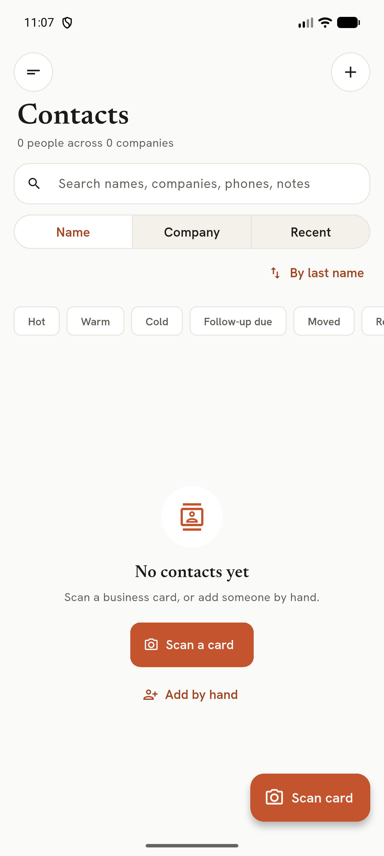
Empty Contacts with empty state
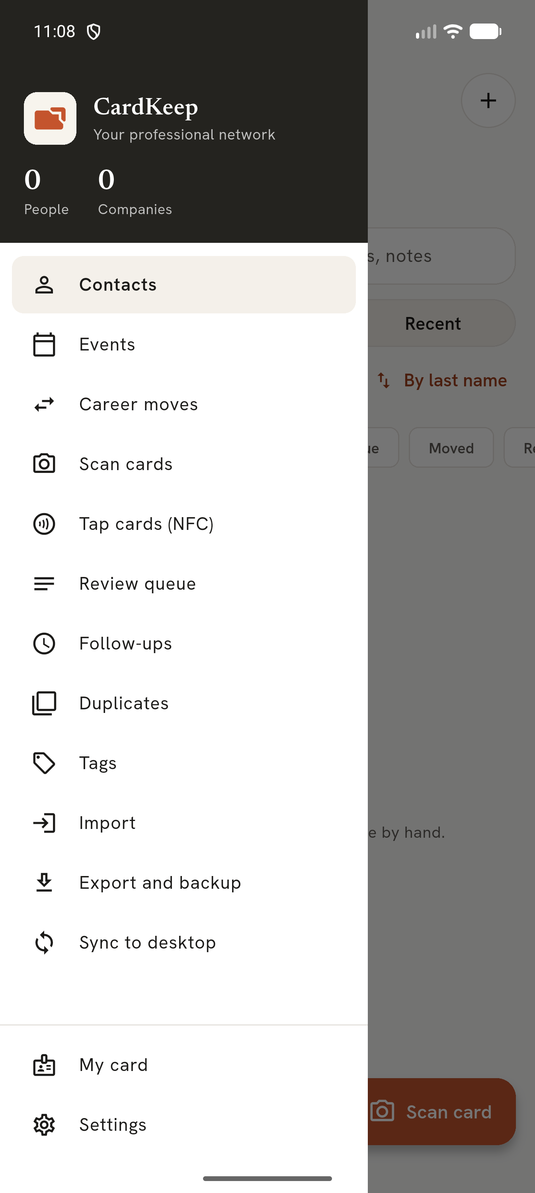
Navigation drawer
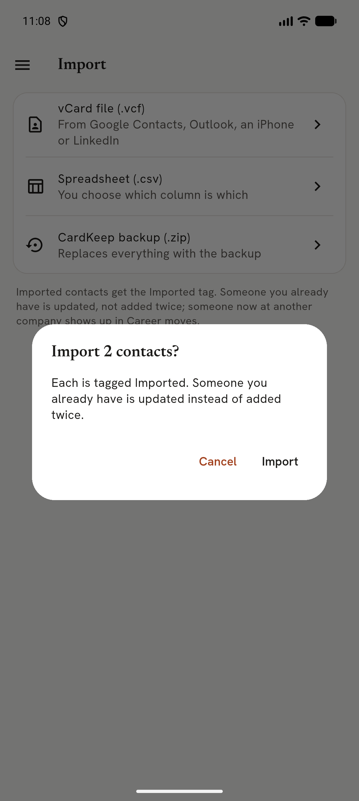
vCard import confirmation
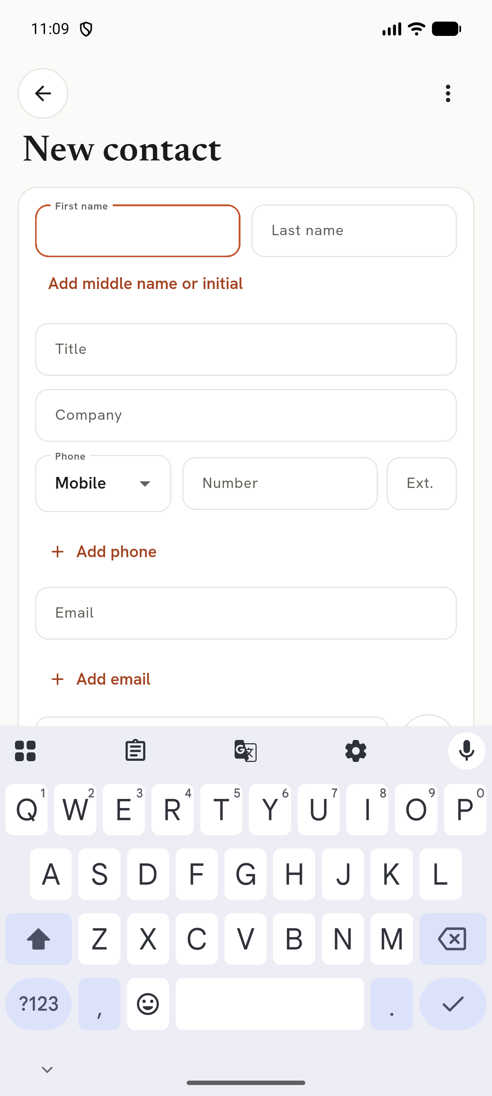
New contact form
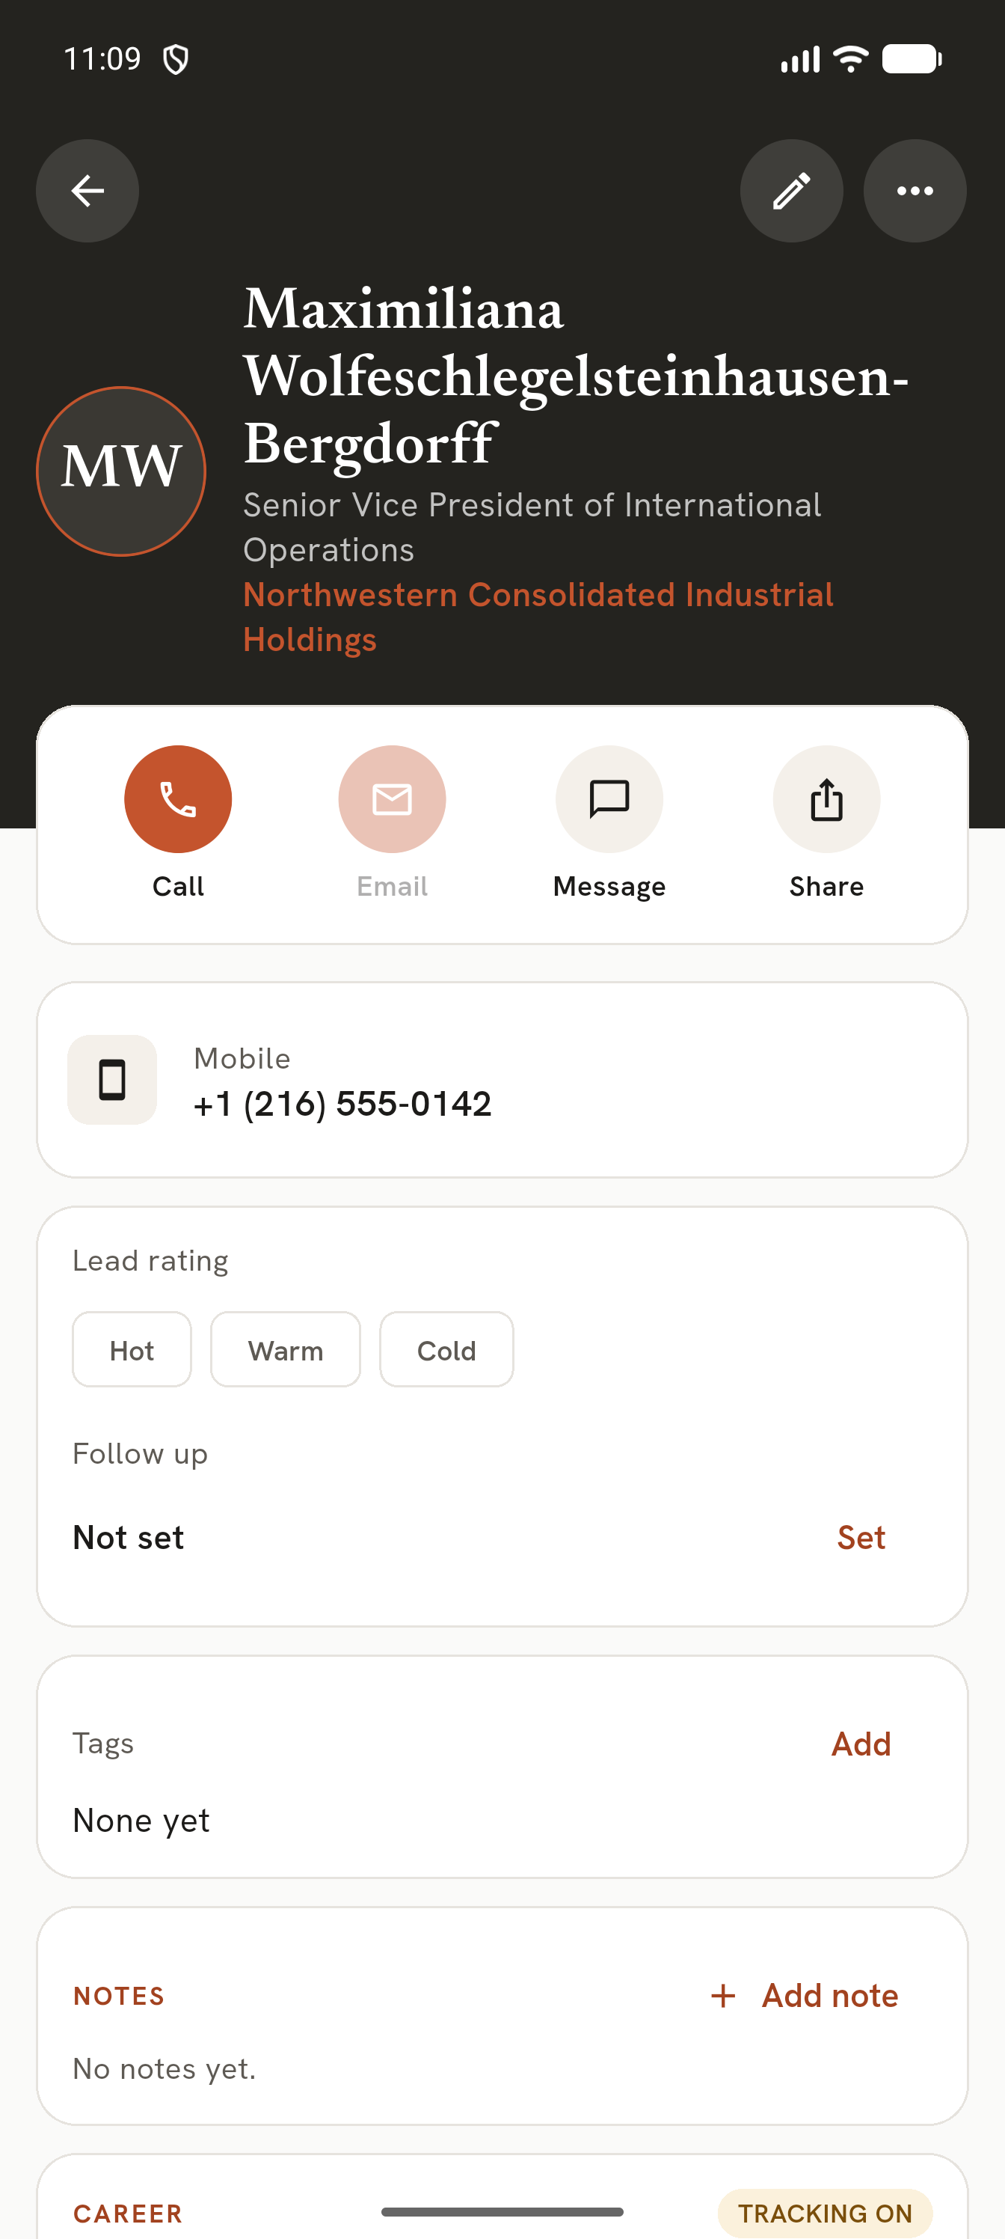
Contact detail with long name/title/company
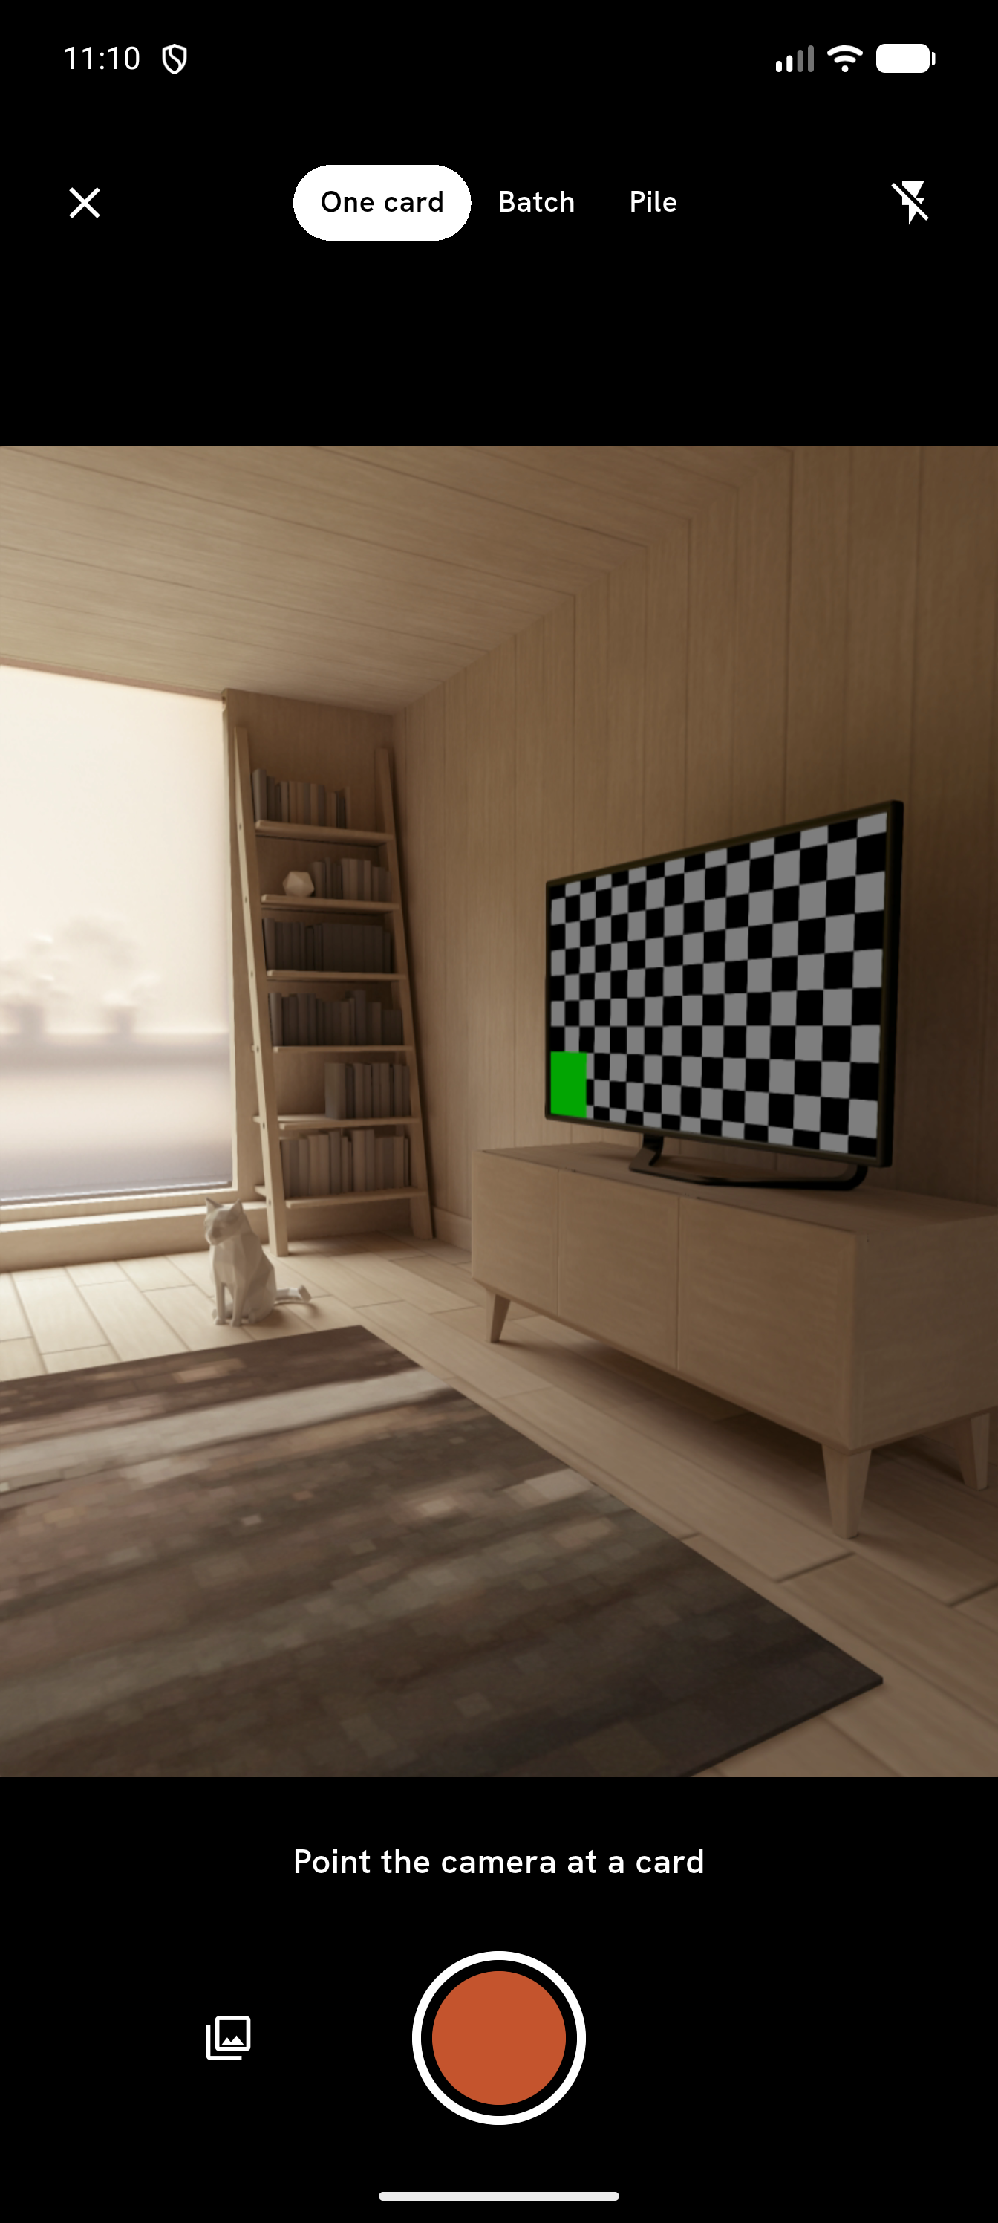
Scan screen (emulator camera scene)
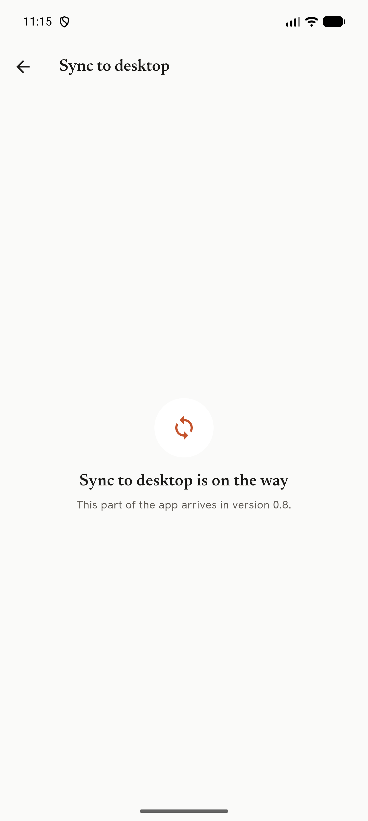
Sync to desktop placeholder
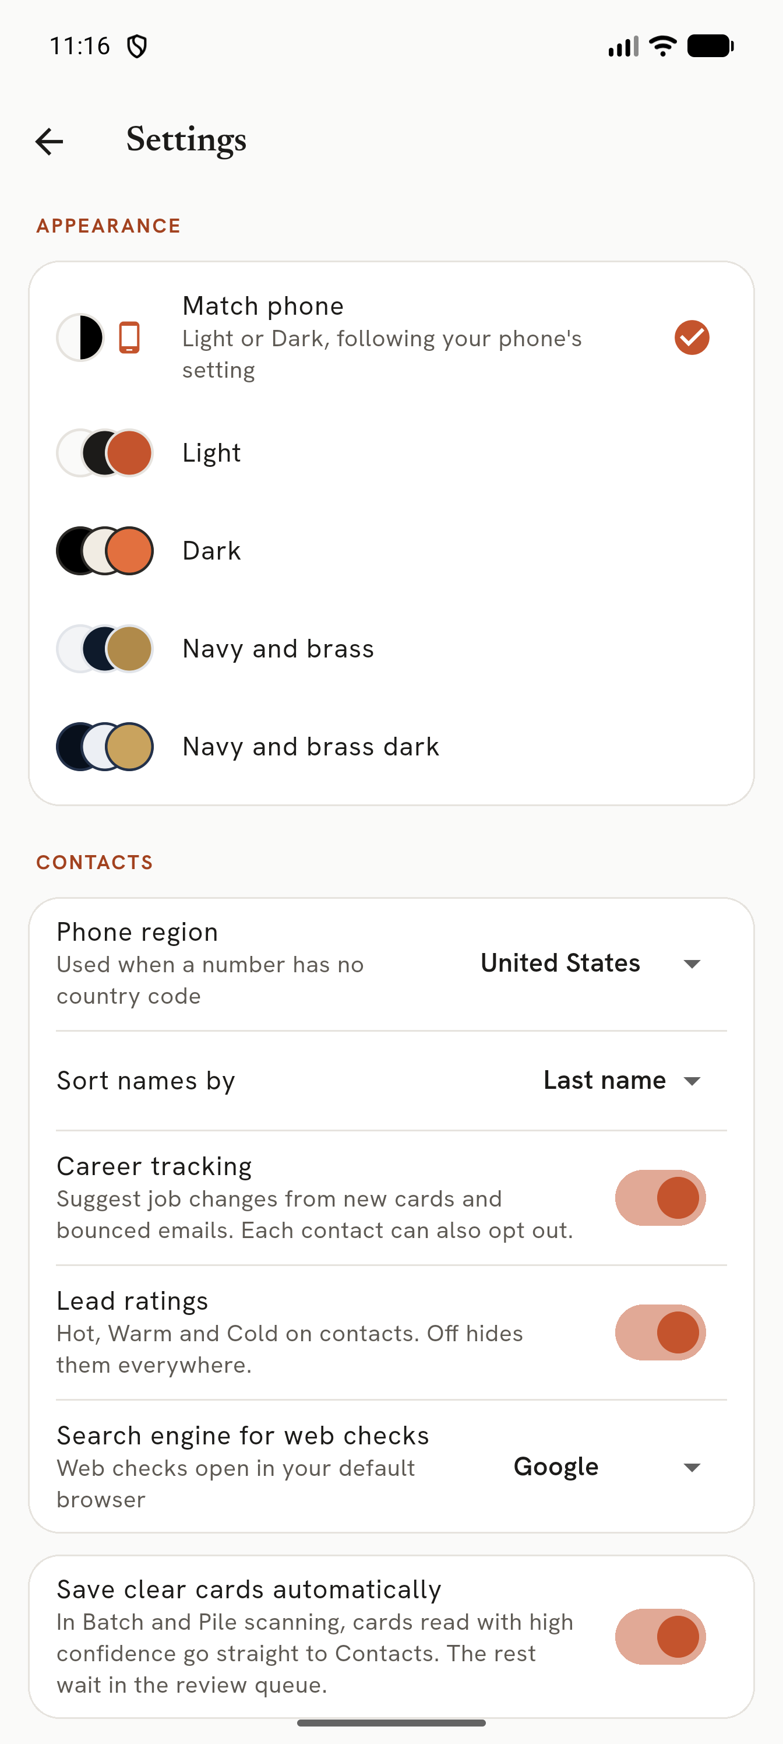
Settings
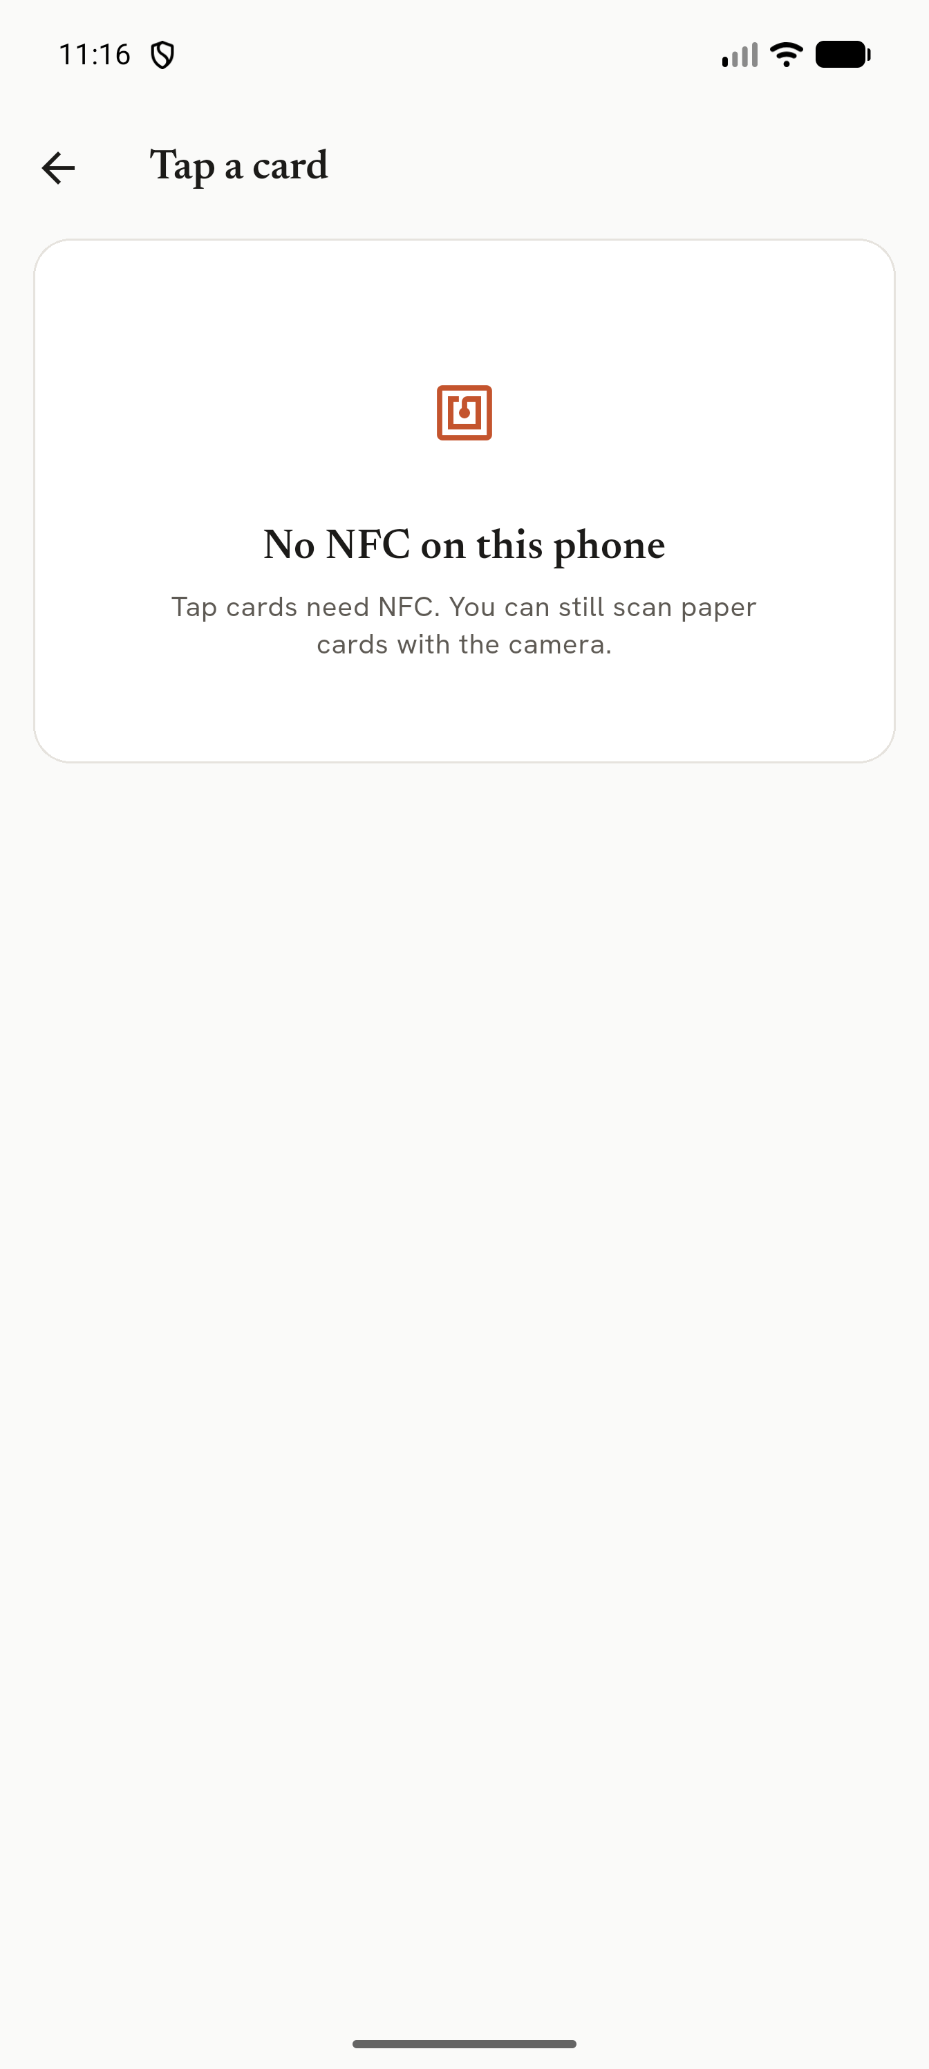
No NFC state
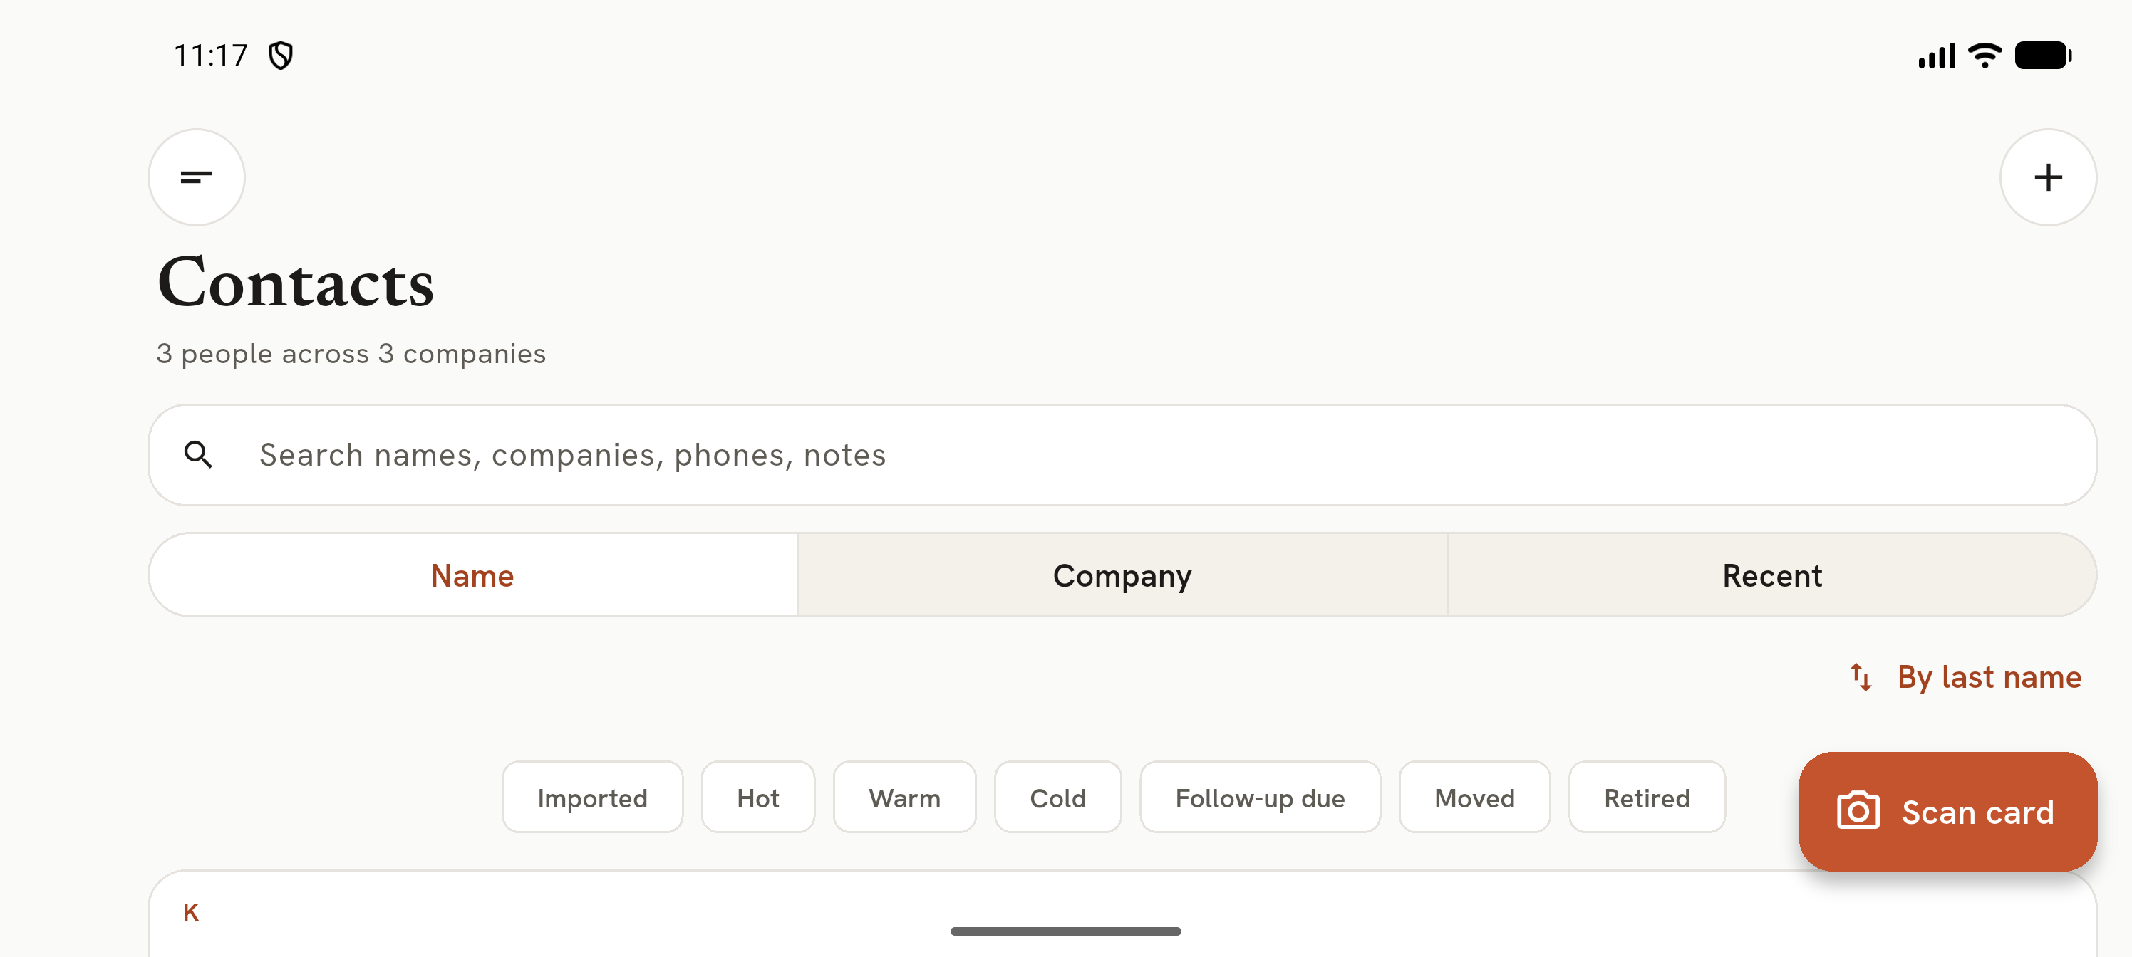
Landscape Contacts
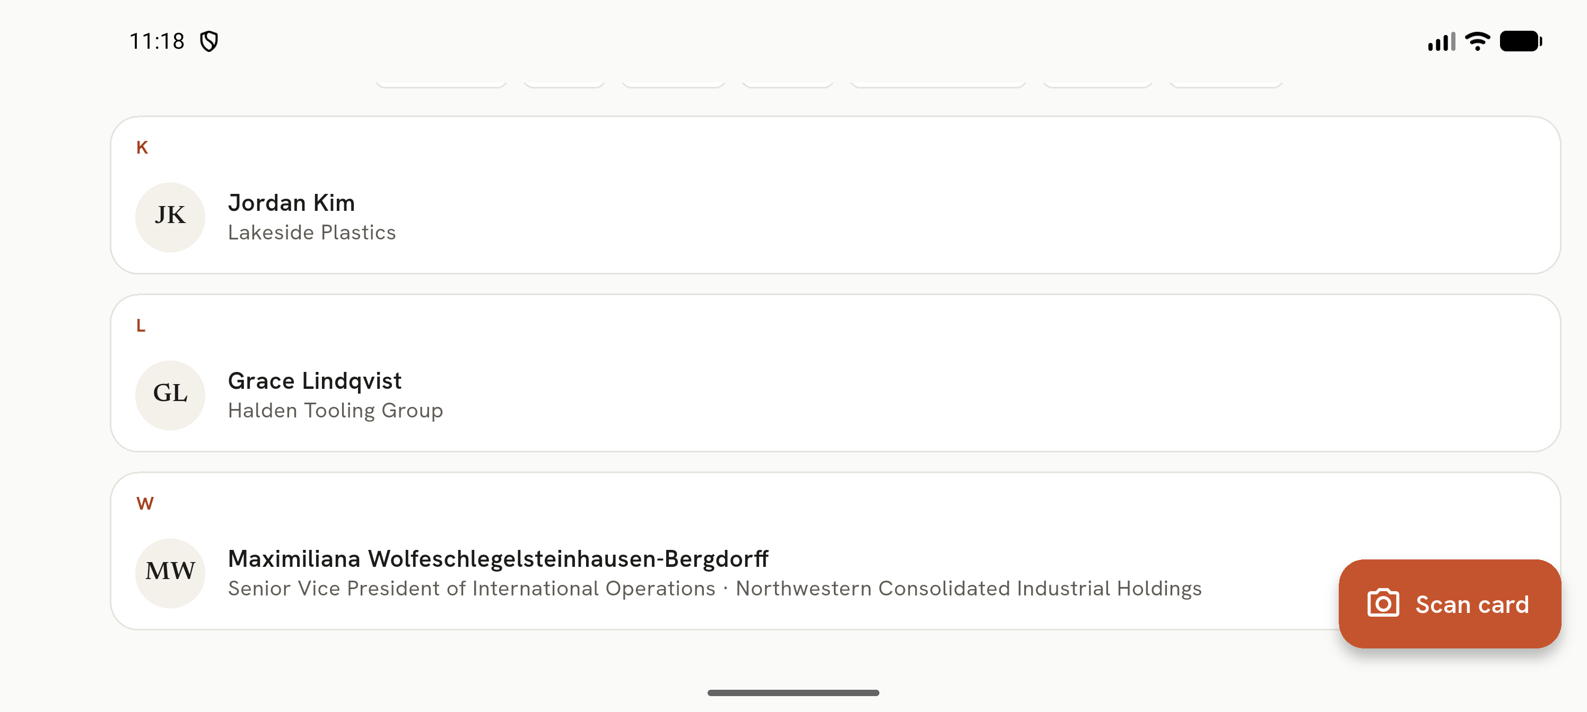
Landscape scrolled
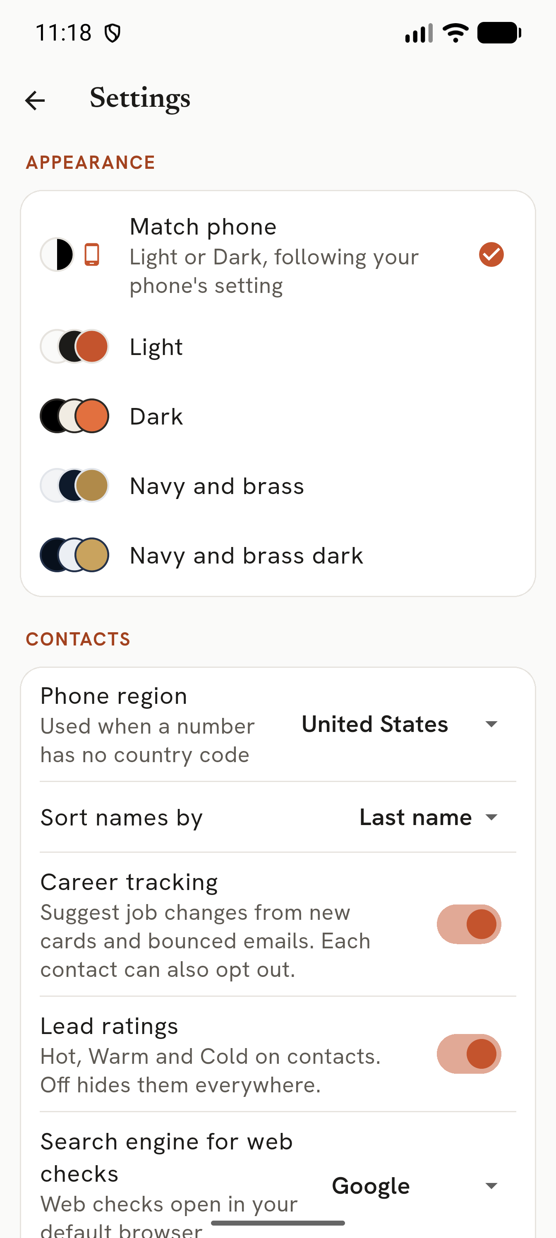
Settings at font 1.3
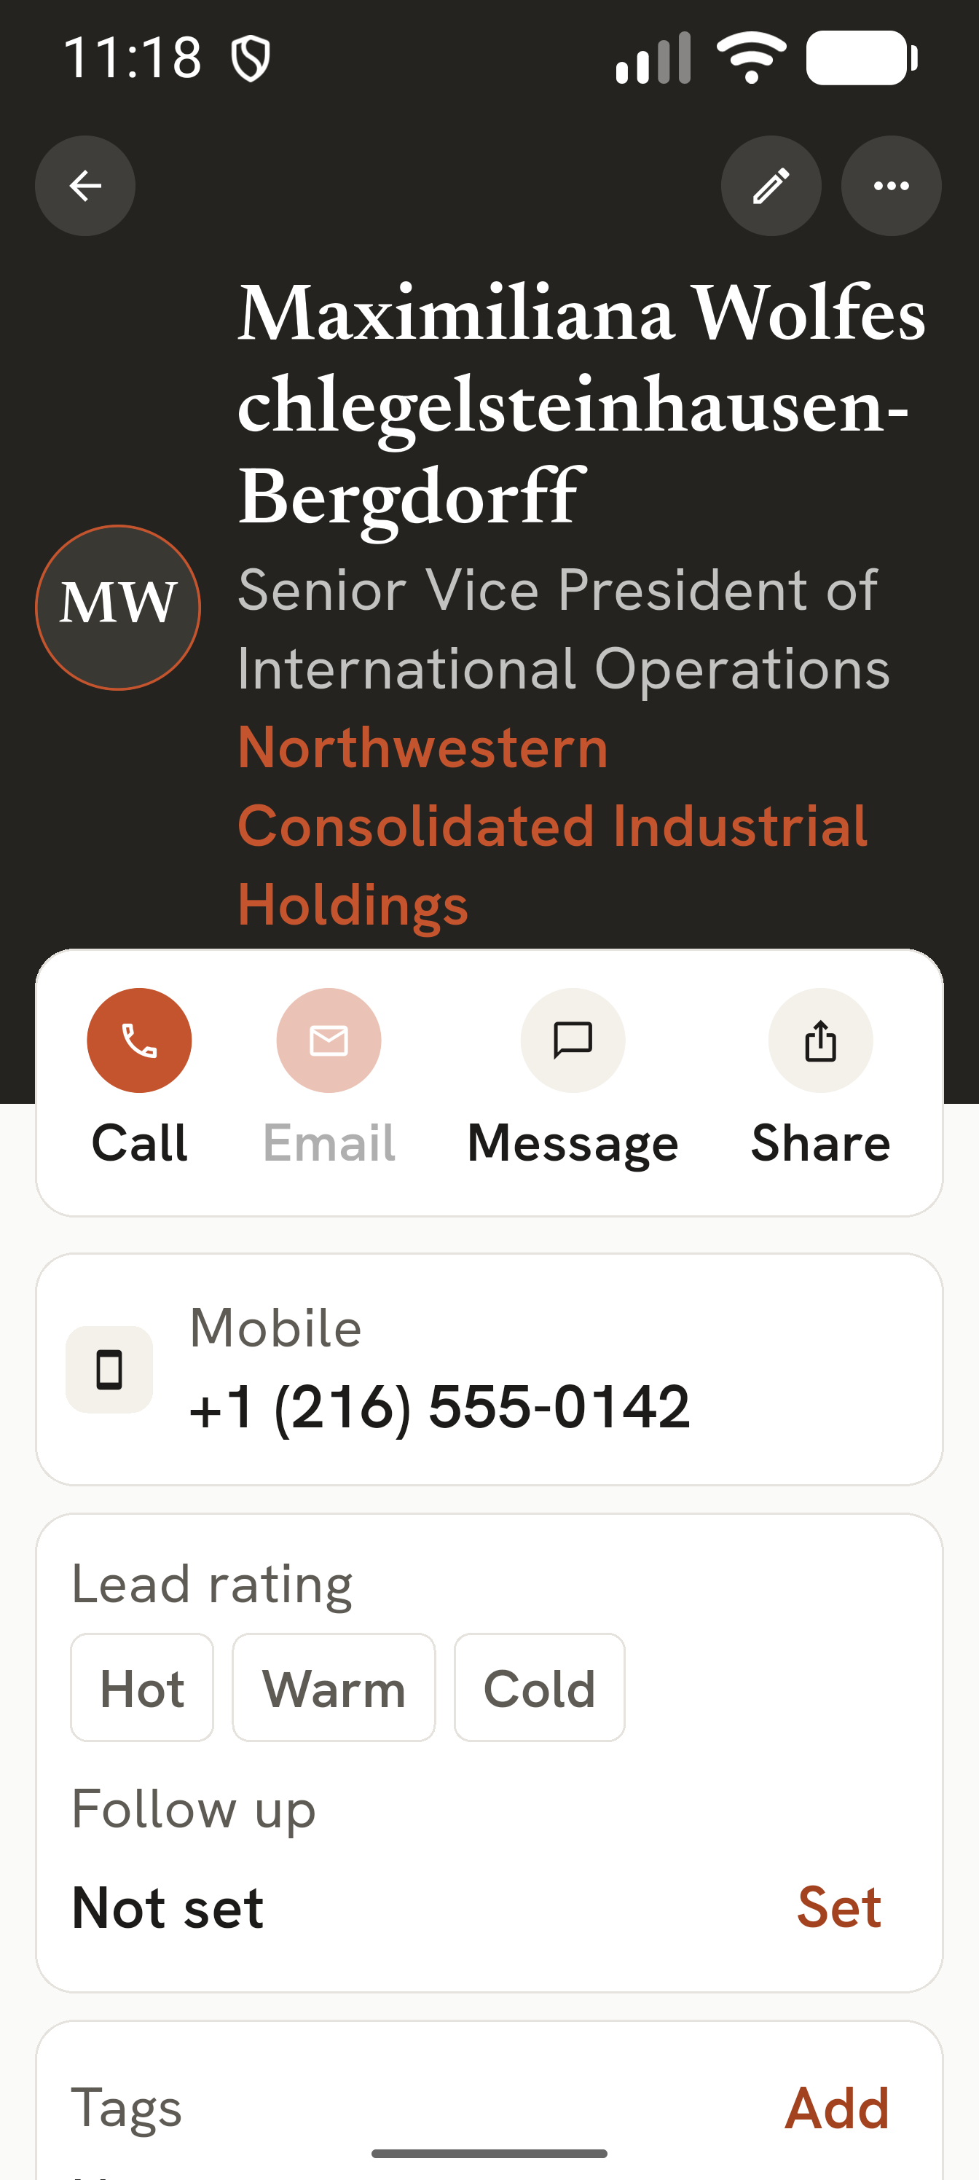
Detail at font 2.0
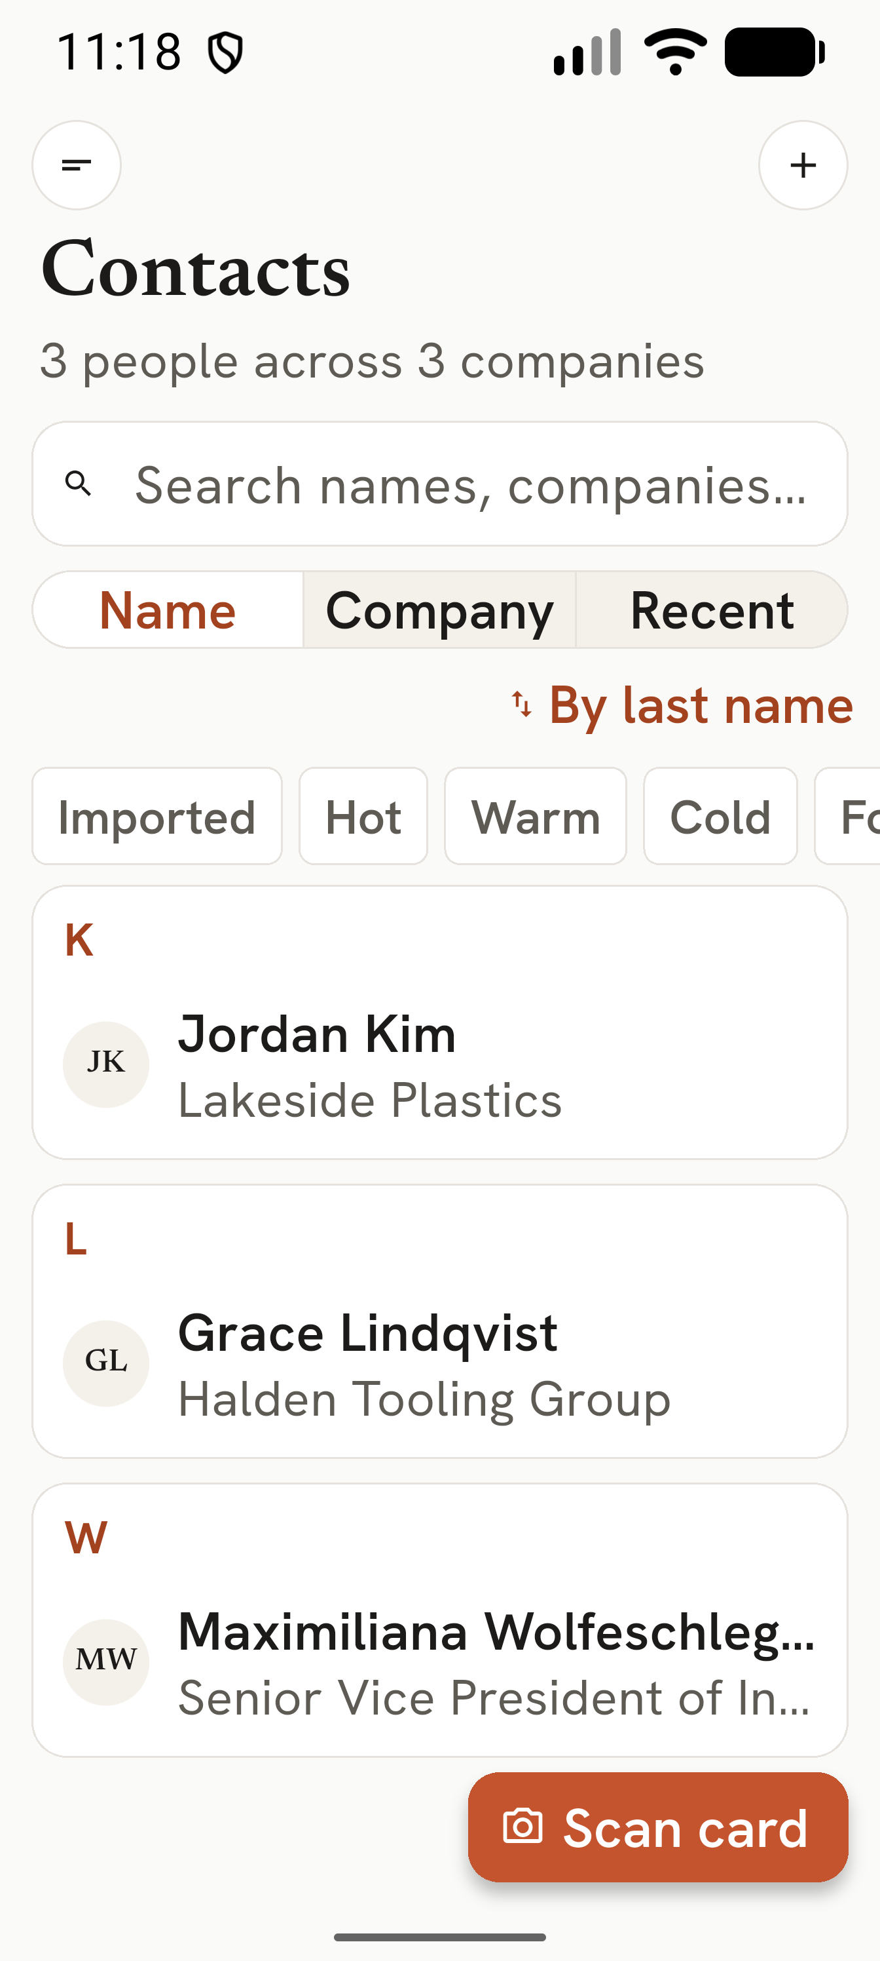
Contacts at font 2.0
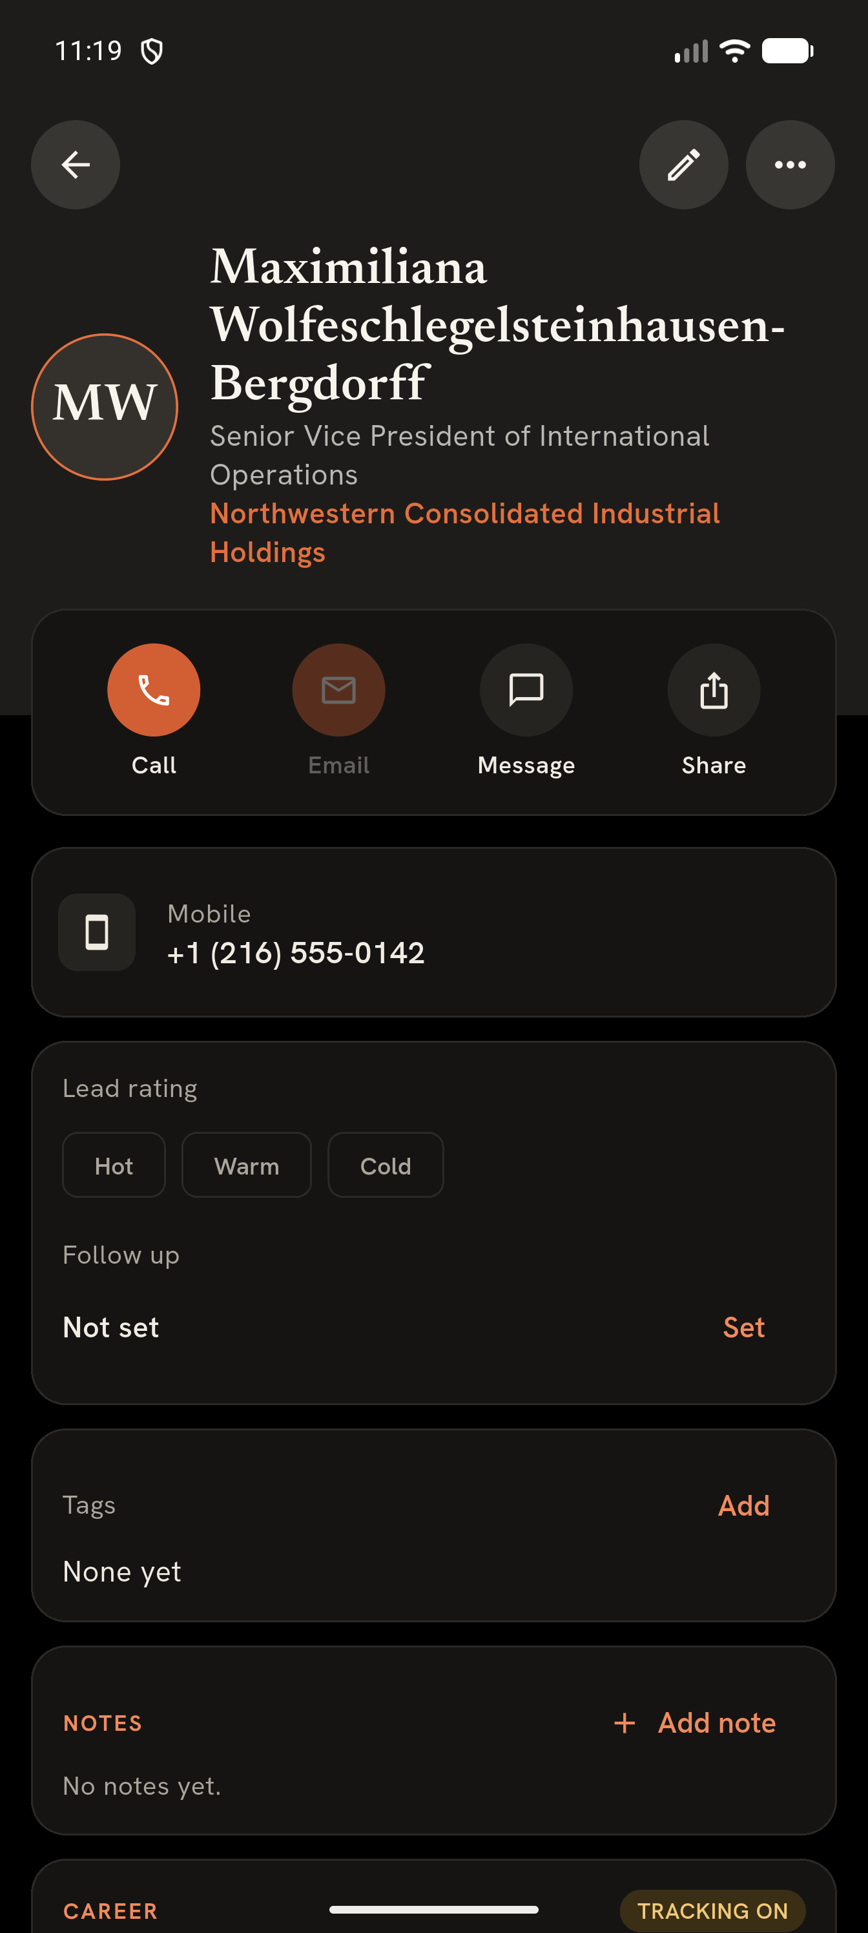
Dark detail
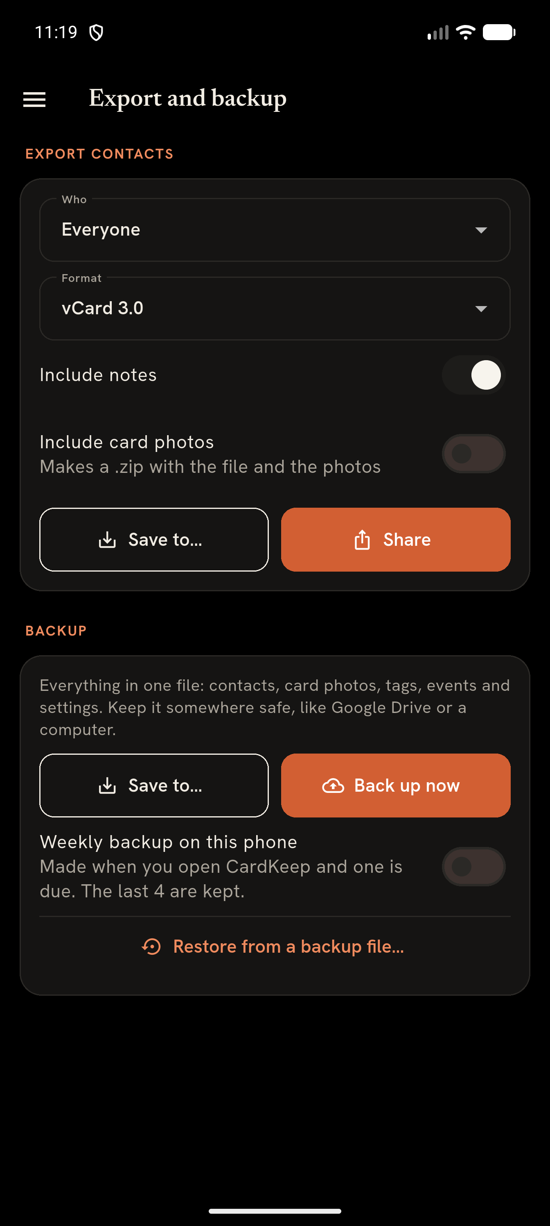
Dark Export and backup

Not covered (BLOCKED)
Real device (Galaxy S25 Ultra) behaviour, NFC, real-camera OCR quality, API 24-35 devices, frame timing (needs a profile build + DevTools), and large-library scroll performance (release build cannot be seeded).

Findings index
ID | Sev | Status
MOB-REL-0001 | S4 | open
MOB-PRV-0001 | S3 | open
MOB-PRV-0002 | S3 | open
MOB-REL-0002 | S3 | open
MOB-STORE-0001 | S3 | open
MOB-STORE-0002 | S3 | open
MOB-REL-0003 | S2 | open
MOB-REL-0004 | S2 | open
MOB-SEC-0001 | S2 | open
MOB-SEC-0100 | S2 | open
MOB-STORE-0003 | S2 | open
MOB-STORE-0004 | S2 | open
MOB-UX-0001 | S2 | open
MOB-A11Y-0001 | S1 | open
MOB-A11Y-0002 | S1 | open
MOB-API-0001 | S1 | open
MOB-BLD-0002 | S1 | open
MOB-BLD-0003 | S1 | open
MOB-BLD-0004 | S1 | open
MOB-PRV-0003 | S1 | open
MOB-PRV-0004 | S1 | open
MOB-REL-0005 | S1 | open
MOB-REL-0006 | S1 | open
MOB-REL-0007 | S1 | open
MOB-REL-0008 | S1 | open
MOB-REL-0009 | S1 | open
MOB-SEC-0002 | S1 | open
MOB-SEC-0003 | S1 | open
MOB-SEC-0006 | S1 | open
MOB-SEC-0101 | S1 | open
MOB-SEC-0102 | S1 | open
MOB-SEC-0103 | S1 | open
MOB-STORE-0005 | S1 | open
MOB-STORE-0006 | S1 | open
MOB-STORE-0007 | S1 | open
MOB-UX-0002 | S1 | open
MOB-BLD-0005 | S0 | open
MOB-PERF-0001 | S0 | open
MOB-SEC-0004 | S0 | open
MOB-SEC-0005 | S0 | open
MOB-SEC-0007 | S0 | open
MOB-AND-0001 | S2 | duplicate (tracked as MOB-SEC-0001)
MOB-BLD-0001 | S2 | duplicate (tracked as MOB-STORE-0002)

